https://www.jica.go.jp/english/our_work/social_environmental/objection/c8h0vm0000013oi1-att/objection.pdf

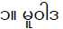 | □
 | □ | 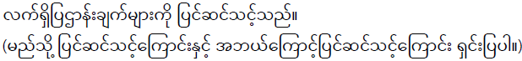
 | □ | 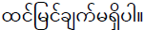
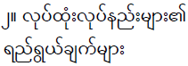 | □
 | □
 | □

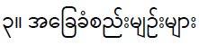 | □
 | □
 | □
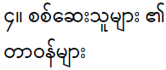 | □
 | □
 | □

https://www.jica.go.jp/english/our_work/social_environmental/objection/c8h0vm0000013oi1-att/objection.pdf

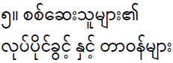 | □
 | □
 | □
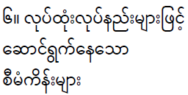 | □
 | □
 | □

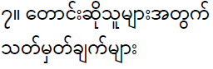 | □
 | □
 | □
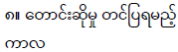 | □
 | □
 | □

https://www.jica.go.jp/english/our_work/social_environmental/objection/c8h0vm0000013oi1-att/objection.pdf

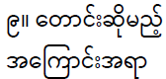 | □
 | □
 | □
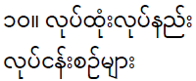 | □
 | □
 | □

 | □
 | □
 | □
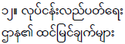 | □
 | □
 | □

https://www.jica.go.jp/english/our_work/social_environmental/objection/c8h0vm0000013oi1-att/objection.pdf

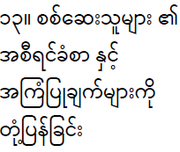 | □
 | □
 | □
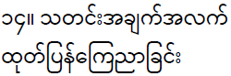 | □
 | □
 | □

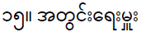 | □
 | □
 | □
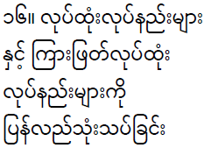 | □
 | □
 | □

https://www.jica.go.jp/english/our_work/social_environmental/objection/c8h0vm0000013oi1-att/objection.pdf

