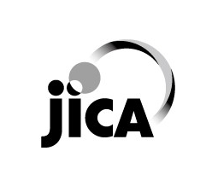

Cooperation Program for the Training of Human Resources, Under the Global Strategic Partnership Between

Mexico-Japan

General information on

Startup Creation & Innovation Ecosystem Development

（起業とイノベーション・エコシステム形成）

JFY 2023
Course No.: 202007332-J008
Course Period in Japan From 25th March, 2024 to 16th November, 2024
This information pertains to one of the JICA Knowledge Co-Creation Programs (Group & Region Focus) of the Japan International Cooperation Agency (JICA) implemented as part of the Official Development Assistance of the Government of Japan based on bilateral agreement between both Governments.
JICA Knowledge Co-Creation Program (KCCP)
The Japanese Cabinet released the Development Cooperation Charter in February 2015, which stated, “In its development cooperation, Japan has maintained the spirit of jointly creating things that suit partner countries while respecting ownership, intentions and intrinsic characteristics of the country concerned based on a field-oriented approach through dialogue and collaboration. It has also maintained the approach of building reciprocal relationships with developing countries in which both sides learn from each other and grow and develop together.” JICA believes that this ‘Knowledge Co-Creation Program’ will serve as a foundation of mutual learning process.

I. Concept
Background
In 1971, the Japan-Mexico Exchange Program has started, which mutually accepts students and young engineers from Mexico and Japan; in February 2010, based on the “Japan-Mexico Joint Statement Strategic Global Partnership in the 21st Century”, the Exchange Program was renewed into the Japan-Mexico Training Program for the Strategic Global Partnership. This program contains long-term courses (between three months and twelve months’ period) and short-term courses (less than three months’ period). Currently, JICA accepts 50 Mexicans participants annually under this scheme.
As we celebrate the 50th anniversary of this training program in 2021 with a value added of “Co-creation between Mexico and Japan”, the course line-up has been completely reviewed, taking into account the compatibility with the priority fields of PRONACES (National Strategy Program) set by the National Council of Humanities, Science and Technology (CONAHCYT) in Mexico, to response strong needs in the areas such as, food security, , and also traditional areas such as art and quality control are set.

This training program aims to develop Mexican human resources, through the implementation of training program based on the Japan-Mexico Joint Statement, thereby contributing to reinforcement of the Mexico-Japan Strategic Global Partnership.

For what?
The purpose of the course is that the participants obtain the know-how and useful tools to establish a social system for recurring innovation through the understanding of challenges and their solutions in Japan with a framework of the industry-academia-government partnership.

For whom?
Applicants should possess a basic knowledge of various innovation theories such as design thinking, lean and open innovation, as well as a startup promotion mindset.

How?
Understanding the innovation creation mechanism, technology development, and formulation process of an innovation ecosystem through an industry-academic partnership, essential knowledge and information for entrepreneurship, and the know-how for the administration of start-up creation from the collaboration with the universities to generate value propositions on how to develop and strength the ecosystem in the region.

II. Description

- Title (Course No. 202007332-J008))
Startup Creation & Innovation Ecosystem Development

- Course Duration in Japan
March to November 2024 (Technical Training Period: 7th May to 15th November 2024: Six months)

25th March: Arrival in Japan※
26th March to 6th May: Briefing, General Orientation and Intensive Japanese Language Class (@JICA Chubu Center)
7th May to 15th November: Technical Training Program (@Kagawa University)
16th November: Departure from Japan

※ The date of arrival in Japan is confirmed for the 25th, but the date of departure from Mexico is not yet confirmed, as it depends on the availability of airline tickets. The departure date from Mexico is scheduled one or two days before the arrival date.

- Target Regions or Countries
Mexico

- Eligible / Target Organization
As a rule, applicants should have experience or intend to dedicate themselves to the creation of an innovation ecosystem such as:
  - Scholars, researchers, graduate, advanced, or gap-year students at Universities
  - Government staffs in charge of innovation creation
  - Staffs from private sector with experience in innovation (startup creators, entrepreneurship mentors, tech transfer staff, etc.
We highly recommend candidates with bachelor’s and master’s degrees as the most suitable fit.

- Capacity (Upper Limit of Participants)
Six (6) participants

- Language
English (Course staff is Spanish speaker, but daily use language for classes will be English.)

- Objective(s)
The purpose of the course is that the participants obtain the know-how and useful tools to establish a social system for recurring innovation (innovation eco-system) through the understanding of challenges and their solutions in Japan with a framework of the industry-academia-government (Triple Helix) partnership.

- Overall Goal
In order to contribute to the PRONACES of the CONAHCYT, special attention was paid to the contents selection of the course. For this particular case, due to the wide coverage of the course, the outcome is expected to meet the various theme of the PRONACES.
This course aims to guide participants in understanding the Japanese ecosystem through diverse case studies, allowing them to identify opportunities for strengthening the local economy by identifying the essential needs of the region and proposing creative solution ideas. This allows the continuity of local economic growth or provides an opportunity to take advantage of economic development. At the same time, we will compare these examples with Mexican counterparts’ cases, so participants will open doors for future collaborations.
For instance, in the strategy of 'Socio-ecological systems,' participants will gain insights into creating a sustainable eco-tourism industry, with a focus on conserving ecosystems and biocultural wealth. We will explore successful examples in Latin America with a balanced perspective, in order to empower communities.
Another opportunity lies in the 'Energy and climate change' strategy. We will showcase some projects performed in this field, considering the broader energy landscape of Japan. This project among others, will offer participants some examples and models that align with PRONACES goals.

- Output and Contents
This course consists of the following components. Details on each component are given below.

The general orientation and Japanese language training program are organized at the JICA Chubu Centre, prior to the technical training, in order to assist the participants in understanding the Japanese way of thinking and adjusting themselves to life in Japan, and thus to facilitate effective training.

Expected Output | Subjects/Agendas | Methodology
1) Expected learning outcome of the technical training | To understand the local industry promotion policies in Japan, and the roles and responsibilities amongst industry, academia and government. | Whitepaper and visit to and benchmark on major science parks in Japan
 | To understand the innovation creation mechanism, technology development, and formulation process of an innovation ecosystem locally through an industry-academic partnership. | Lecture , seminar and visit to local companies and authorities
 | To obtain fundamental/essential knowledge and information for entrepreneurship. | Lecture, seminar and books such as “Disciplined Entrepreneurship”
 | To understand the current situation and challenges of technology transfer from Japan to overseas. | Lecture and interviews
 | To obtain the know-how for entrepreneurship and administration through actual cases of start-up creation from universities and local collaboration. | Visits to local startup companies
 | To acquire the concept of enterprise management through concrete project works. | Project works
 | To generate value propositions on how to develop and strengthen the ecosystem in the region (Refer to the figure in Annex) | Project works
2) Specific Contents | Attendance to lectures at Kagawa University such as business concept creation, risk management | Various lectures
 | Interaction with the education program on entrepreneurship of Kagawa University (Startup club) | Discussion with club members
 | Site visits to local enterprises and plants | Visit to local companies
 | Participation in startup network activities with Latin American universities with which Kagawa University collaborates (Global first penguin club: G1PEC) | G1PEC
 | Exchange opinions with university students of the product, media & engineering-design course. | Discussions with university students
3) Final Report | Based on the research performed, the participants will be expected to compile the final report on their research and make a brief presentation at the end of the training. It is also expected that they include a value proposition of how to use the acquired knowledge in their field whenever they come back to Mexico. This process will be considered as the “Action Plan” to accomplish their outcome. | Seminars, coaching and discussion with fellow researchers

Note: the objective of the program is to learn about the Japanese ecosystem and the research topic will be assigned, the project will be theoretical, and the data is the property of JICA and the hosting University. The program is not intended to create or support any personal entrepreneurship inside or outside of Japan.

<Structure of the Course>
Topic outline (subject to minor changes)

Week 1 – 8 Base knowledge acquisition (in Japan)
Lectures, Weekly seminar（by courses, by individual）
Week 9 – 16 Interaction with related departments and organizations (in Japan)
Startup clubs, Public organizations, Research groups, Weekly seminar（with focus on individual theme）
Week 17 – 24 Data collection for the research and analysis
Paper reading, visit and interview related enterprises, analysis of the data, concept creation
Week 24 – 28 Documentation and preparation of the presentation
Final report writing and review in Kagawa University with participation by JICA and professors of the university, and presentation at G1PEC.

III. Eligibility and Procedures
- Expectations to the Applying Organizations
Applicants must attach Annex about the followings to demonstrate the ability to accomplish this course:
- Educational background related to the course.
- Work experience related to the course (if you are working on any specific project, please describe and explain what kind of skill you want to acquire through this course).

- Nominee Qualifications
Applying organizations are expected to select nominees who meet the following qualifications.
- Essential Qualifications
  - Applicants should possess a basic knowledge of various innovation theories such as: design thinking, lean and open innovation.
  - As a rule, applicants should be professionals who dedicate themselves to the creation of an innovation ecosystem such as:
  - Scholars, researchers, graduate, advanced, or gap-year students at Universities
  - Government staff in charge of innovation creation
  - Staff from private sector with experience in innovation (startup creators, entrepreneurship mentors, tech transfer staff, etc.)
  - Applicants must have good commands of English in terms of conversation/documentation for the successful completion of the course. English is required to attend some lectures given in English (TOIEC 800 level).
  - Applicants must be fully committed to the training.
5) Applicants must declare honestly in the Medical History.
To reduce the risk of worsening symptoms associated with respiratory tract infection, please be honest to declare in the Medical History. ※1: (QUESTIONNAIRE ON MEDICAL STATUS RESTRICTION of the application form) if you have been a patient of following illnesses; Hypertension / Diabetes / Cardiovascular illness / Heart failure / Chronic respiratory illness.
Any person in any health conditions is eligible to apply for this course, however the health conditions of all applicants will be verified at the moment of selection in order to that participants will be in good health during the training in Japan.

※1: Considering the length of the course exceeds eight months and that during this period JICA could not offer proper health care assistance for periodical exams, medical appointments, eventual emergency care (if needed) required or delivery of birth during gestation, pregnant applicants are not recommended to apply due to the potential risk of health and life issues of mother and fetus. And also, it is recommended that to do dental treatment in the case of that you have dental problem because dental treatment is not be covered by the insurance offered.

6) Applicants must not be presently serving in the military.
7) Applicants must attach annex about the followings to demonstrate the ability to accomplish this course:
• Educational background related to the course; Bachelor or master in the field of engineering, business, and sociology.
• Experience for two years or more in the field of innovation, eco-system creation, and entrepreneurial activities. If you are working on any specific project, please describe and explain what kind of skill you want to acquire through this course.

- Recommended Qualifications
  - Expectations for the participants: People that have an interest in innovation and entrepreneurship, want to learn basic principles on topics and would like to know the Japanese ecosystems and its challenges.
  - Age:No limitation, but between the ages of twenty-two (22) and thirty-five (35) years old recommended
  - Gender Equality and Women’s Empowerment: Women are encouraged to apply for the program. JICA makes a commitment to promote gender equality and women’s empowerment, providing equal opportunity for all applicants regardless of sexual orientation and gender identity.

- Required Documents for Application
- Application Form: The Application Form is available at the JICA Mexico office
* If you have any difficulties/disabilities which require assistance, please specify necessary assistances in the QUESTIONNAIRE ON MEDICAL STATUS RESTRICTION (1-(c)) of the application form. Information will be reviewed and used for reasonable accommodation.
- Photocopy of Passport: You should submit it with the application form if you possess your passport which you will carry when entering Japan for this program. If not, you are requested to submit its photocopy as soon as you obtain it.
*The following information should be included in the photocopy:
Name, Date of Birth, Nationality, Sex, Passport Number and Expiry Date
- English Score Sheet: to be submitted with the application form, if the nominees have any official English examination scores. (e.g., TOEFL, TOEIC, IELTS)
- Inception Report: to be submitted with the application form (Please read Annex "Inception Report" for detailed information.).

- Procedures for Application and Selection
- Selection
Primary screening is conducted at CONAHCYT after receiving official documents from JICA. JICA Shikoku Center will consult with concerned organizations in Japan in the process of final selection. Applying organizations with the best intentions to utilize the opportunity will be highly valued.

The Government of Japan will examine applicants who belong to the military or other military-related organizations and/or who are enlisted in the military, taking into consideration of their duties, positions in the organization and other relevant information in a comprehensive manner to be consistent with the Development Cooperation Charter of Japan.

- Notice of Acceptance
CONAHCYT will notify the results not later than December, 2023.

- Conditions for Participation
The participants of KCCP are required
- to strictly observe the course schedule,
- not to change the air ticket (and flight class and flight schedule arranged by JICA) and lodging by the participants themselves,
- to understand that leaving Japan during the course period (to return to home country, etc.) is not allowed (except for programs longer than one year),
- not to bring any family members to stay with (Visit by the participant’s family is not prohibited as long as the participation to the training program is not disturbed.),
- to carry out such instructions and abide by such conditions as may be stipulated by both the nominating Government and the Japanese Government in respect of the course,
- to observe the rules and regulations of the program implementing partners to provide the program or establishments,
- not to engage in political activities, or any form of employment for profit,
- to discontinue the program, should the participants violate the Japanese laws or JICA’s regulations, or the participants commit illegal or immoral conduct, or get critical illness or serious injury and be considered unable to continue the course. The participants shall be responsible for paying any cost for treatment of the said health conditions except for the medical care stipulated in (3) of “5. Expenses”, “IV. Administrative Arrangements”,
- to return the total amount or a part of the expenditure for the KCCP depending on the severity of such violation, should the participants violate the laws and ordinances,
- not to drive a car or motorbike, regardless of an international driving license possessed,
- to observe the rules and regulations at the place of the participants’ accommodation, and
- to refund allowances or other benefits paid by JICA in the case of a change in schedule.
- in case of natural disaster or any possible contingency that makes unfeasible to conduct this course in Japan, it may be offered remotely or canceled. In the case of conducting training program on-line, the training period may be subject to change.

IV. Administrative Arrangements
- Organizer (JICA Center in Japan)
Center: JICA Shikoku Center
Program Officer: Mr. Hiromu Iwataki (Iwataki.Hiromu@jica.go.jp)
- Implementing Partner
Name: Dr. Naotaka HIRAMI, Kagawa University
URL: https://www.kagawa-u.ac.jp/en/
https://nhirami.com/
Remark: Dr. Hirami is a professor in charge, from the Faculty of Engineering and Design, Kagawa University.
- Travel to Japan
- Air Ticket: In principle, JICA will arrange an economy-class round-trip ticket between an international airport designated by JICA and Japan.
- Travel Insurance: Coverage is from time of arrival up to departure in Japan. Thus, traveling time outside Japan (include damaged baggage during the arrival flight to Japan) will not be covered.
- Accommodation in Japan
Basically, JICA will arrange the accommodation(s) with Kagawa University for the participants in Japan: To be determined.
- Expenses
The following expenses in Japan will be provided by JICA
- Allowances for meals, living expenses, outfits, and shipping and stopover.
- Expenses for study tours (basically in the form of train tickets).
- Medical care for participants who become ill after arriving in Japan (the costs related to pre-existing illness, pregnancy, or dental treatment are not included).
- Expenses for program implementation, including materials.
- For more details, please see “III. ALLOWANCES” of the brochure for participants titled “KENSHU-IN GUIDE BOOK,” which will be given before departure for Japan.
*Link to JICA HP (English/French/Spanish/Russian): https://www.jica.go.jp/english/our_work/types_of_assistance/tech/acceptance/training/index.html

- Pre-departure Orientation
A pre-departure orientation will be held at JICA Mexico office, to provide Participants with details on travel to Japan, conditions of the course, and other matters.

*YouTube of “Knowledge Co-Creation Program and Life in Japan” and “Introduction of JICA Center” are viewable from the link below.
Image videos of 'Introduction of JICA Center (YouTube)' show the following information of JICA Centers: Location, Building, Entrance, Reception(Front desk), Lobby, Office, Accommodation(Room), Amenities(Hand dryer), Bathroom(Shower and Toilet), Toiletries, Restaurant, Laundry Room(Washing machine, Iron), ICT Room(Computer for participants), Clinic, Cash dispenser, Gym, Neighborhood

Part I: Knowledge Co-Creation Program and Life in Japan
- English ver. | https://www.youtube.com/watch?v=SLurfKugrEw
Spanish ver. | https://www.youtube.com/watch?v=m7l-WlQSDjI
Part II: Introduction of JICA Centers in Japan
JICA Shikoku | https://www.jica.go.jp/shikoku/english/office/index.html

V. Other Information

Following chart is global image of innovation ecosystem sought by Kagawa Univ.

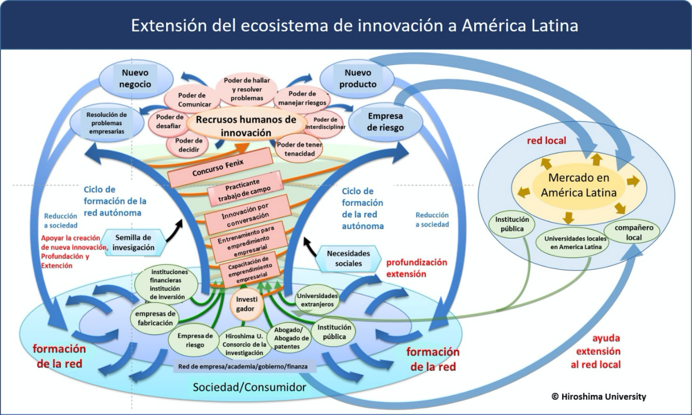
Figure 1. The innovation ecosystem sought by Kagawa University involves the creation, development and strengthening of the networks between academia, government, industry and society, establishing a cycle of recurring collaboration between them. As a result, the creation of new and innovative venture companies will be possible. Likewise, the interest in expanding this collaboration network to Latin America not only favors internationalization, but also provides opportunities for both countries to incorporate new technologies and boost the economic growth of the local regions involved.

VI. Annex

Japan-Mexico Training Program for the Strategic Global Partnership
JFY 2023-2024
Full Name
Contact information | Tel.  Fax.  Email.
TOEFL Score | Total (PBT/CBT/iBT) test date: / /

Educational background related to industry-academia-government partnership / the social system for recurring innovation (innovation eco-system).å

For Your Reference

JICA and Capacity Development
Technical cooperation is people-to-people cooperation that supports partner countries in enhancing their comprehensive capacities to address development challenges by their own efforts. Instead of applying Japanese technology per se to partner countries, JICA’s technical cooperation provides solutions that best fit their needs by working with people living there. In the process, consideration is given to factors such as their regional characteristics, historical background, and languages. JICA does not limit its technical cooperation to human resources development; it offers multi-tiered assistance that also involves organizational strengthening, policy formulation, and institution building.

Implementation methods of JICA’s technical cooperation can be divided into two approaches. One is overseas cooperation by dispatching experts and volunteers in various development sectors to partner countries; the other is domestic cooperation by inviting participants from developing countries to Japan. The latter method is the Knowledge Co-Creation Program, formerly called Training Program, and it is one of the core programs carried out in Japan. By inviting officials from partner countries and with cooperation from domestic partners, the Knowledge Co-Creation Program provides technical knowledge and practical solutions for development issues in participating countries.

The Knowledge Co-Creation Program (Group & Region Focus) has long occupied an important place in JICA operations. About 400 pre-organized course cover a wide range of professional fields, ranging from education, health, infrastructure, energy, trade and finance, to agriculture, rural development, gender mainstreaming, and environmental protection. A variety of programs is being customized by the different target organizations to address the specific needs, such as policy-making organizations, service provision organizations, as well as research and academic institutions. Some programs are organized to target a certain group of countries with similar developmental challenges.

Japanese Development Experience
Japan, as the first non-Western nation to become a developed country, built itself into a country that is free, peaceful, prosperous and democratic while preserving its tradition. Japan will serve as one of the best examples for our partner countries to follow in their own development.

From engineering technology to production management methods, most of the know-how that has enabled Japan to become what it is today has emanated from a process of adoption and adaptation, of course, has been accompanied by countless failures and errors behind the success stories.
Through Japan’s progressive adaptation and application of systems, methods and technologies from the West in a way that is suited to its own circumstances, Japan has developed a storehouse of knowledge not found elsewhere from unique systems of organization, administration and personnel management to such social systems as the livelihood improvement approach and governmental organization. It is not easy to apply such experiences to other countries where the circumstances differ, but the experiences can provide ideas and clues useful when devising measures to solve problems.

JICA, therefore, would like to invite as many leaders of partner countries as possible to come and visit us, to mingle with the Japanese people, and witness the advantages as well as the disadvantages of Japanese systems, so that integration of their findings might help them reach their developmental objectives.

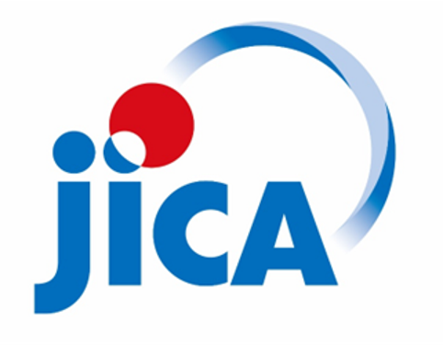

Contact Information for Inquiries
For inquiries and further information, please contact the JICA Mexico office or the Embassy of Japan. Further, address correspondence to:

JICA Shikoku Center (JICA Shikoku)
Address:First Floor, Kagawa Sanyu Bldg., 3 Kajiya-machi, Takamatsu City, Kagawa Prefecture
Tel: 087-821-8824
Fax: 087-822-8870
Email: jicaskic@jica.go.jp

https://www.mofa.go.jp/announce/announce/2011/2/PDF/0222_02_01.pdf

