Form5. QUESTIONNAIRE

Please fill in the following questions and send this with Application Form.
- Your name for the certificate:
Your calling name:

- Your valid e-mail address which can be reached anytime throughout the program.
*Please note that this e-mail address will be shared among organizers and participants.

- A phone number where you can be reached in the event that you lose internet connectivity during the online program:

- Have you ever used “Zoom Webinar and/or Meeting”? : Yes / No

- Where do you connect this online program from?
Home / Office / JICA office / Others:

6. Would you be able to secure a computer and/or a stable internet connection during the online program? Please check the box below:
□ I have a computer with a stable internet connection.
□ I have a computer but need assistance from the JICA Office for internet connection.
□ I need assistance from the JICA office for both computer and internet connection.

- What kind of cases would you like to share as a good practice or a challenging case to discuss with the other participants during the course? __________________________________________________________

- Do you use any messenger Apps? (e.g. Facebook Messenger, WhatsApp) If yes, please indicate the name of the App and your account name - the organizer may reach out to you through the App during the program period.
Yes (Name of the App and your account: ) / No

- Please check your internet speed at the same local time that you would join in this training program by clicking “GO” in the following link. And submit a screenshot of the result. https://www.speedtest.net/
*Screenshot example:

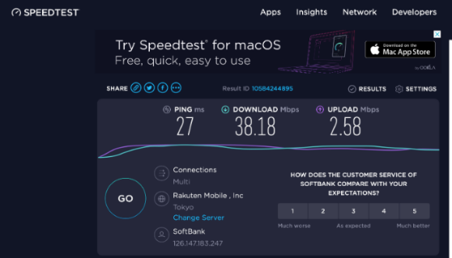

Paste Your Screenshot Here

- Questions/requests if you have any

End of Questionnaire

