バングラデシュ・ビジネス関連ニュース（2018年11月）
～主要ニュースの抜粋版～

（為替レート 1タカ＝1.341円）
産業別ニュース
農林水産 |  | 【PepsiCo sees massive potential in Bangladesh】  バングラデシュにおけるソフトドリンク飲料の需要拡大が期待できる。  The soft drinks industry has tremendous potential in Bangladesh, which is a home to a big pool of young population and has posted healthy economic growth in the last 10 years....... 11月5日Daily Star紙  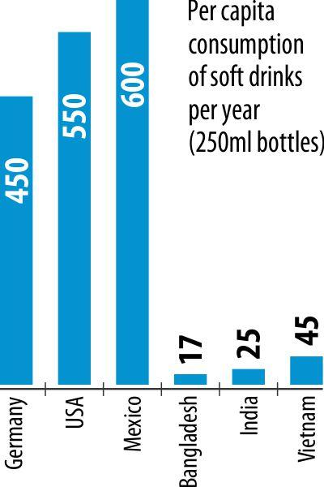  【Processed jackfruit products now on export list】  欧州向けにジャックフルーツの輸出が開始される。Bangladesh will start exporting processed jackfruit products to the EU countries early next year, which experts believe will diversify the country's export basket...... 11月10日 Financial Express紙  
アパレル |  | 【Lotto bullish on Bangladesh】  スポーツウェアショップを倍増させる。Lotto, the Italian Sportswear brand, plans to double its stores in Bangladesh to 300 within the next two years, spurred by sizeable youth population and rising disposable income....... 11月23日Daily Star紙  【Local spinners missing out on cheap supply】  ウズベキスタンは綿花の産地。しかし2007年以降、同国における児童労働などの問題により、欧州系バイヤーがウズベキスタン製の綿花使用を禁じている。それ以降、バングラデシュはインド、アフリカ等から輸入するようになったが、それらはウズベキスタン製の綿花よりは高価なもので、バングラデシュの紡績工などの収益が圧迫されている。  Bangladesh could not use the cheap cotton from Uzbekistan over the last 10 years or so because of a restriction imposed by major clothing retailers due to use of child or forced labour by the Uzbek government in cotton harvesting...... 11月6日Daily Star紙  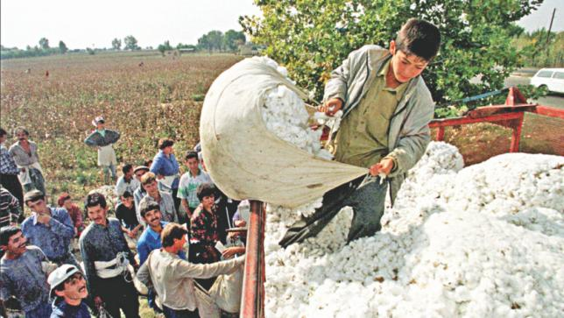
金融 |  | 【One-third life insurance claims unsettled: IDRA】  生命保険の不払い率は依然として高い。Some 33 percent life insurance claims in Bangladesh remain unsettled thanks to weak financial health and lack of governance, and in the process erode people's trust in insurers...… 11月11日Daily Star紙
交通 |  | 【Airport-Kamalapur metro rail among five JICA-funded projects】  日本政府が支援する第40次ローンパッケージ（MRT1号線含む）の方向性固まる。The government agencies have decided to receive a sizeable fund under the Japanese 40th loan package to implement five development projects...…. 11月6日Financial Express紙  【Development of all Bangladesh airports in progress】  空港の開発進む。ダッカ空港の拡張工事は日本政府が支援する。Civil Aviation Authority of Bangladesh (CAAB) held a public hearing on November 11 for the first time to raise accountability and transparency of the services rendered at airports in the country, including country's main gateway by air – Hazrat Shahjalal International Airport. …11月12日Bangladesh Monitor紙  【“MRTs are the only long-term solution for traffic problems in Dhaka”】  ダッカの渋滞問題をMRTで解決する。How did the concept of Dhaka Metro Rail come to be? What is the background of the project? The first study looking into solution to traffic problems in Dhaka city was carried out in the mid- 1980s. …11月15日Daily Star紙  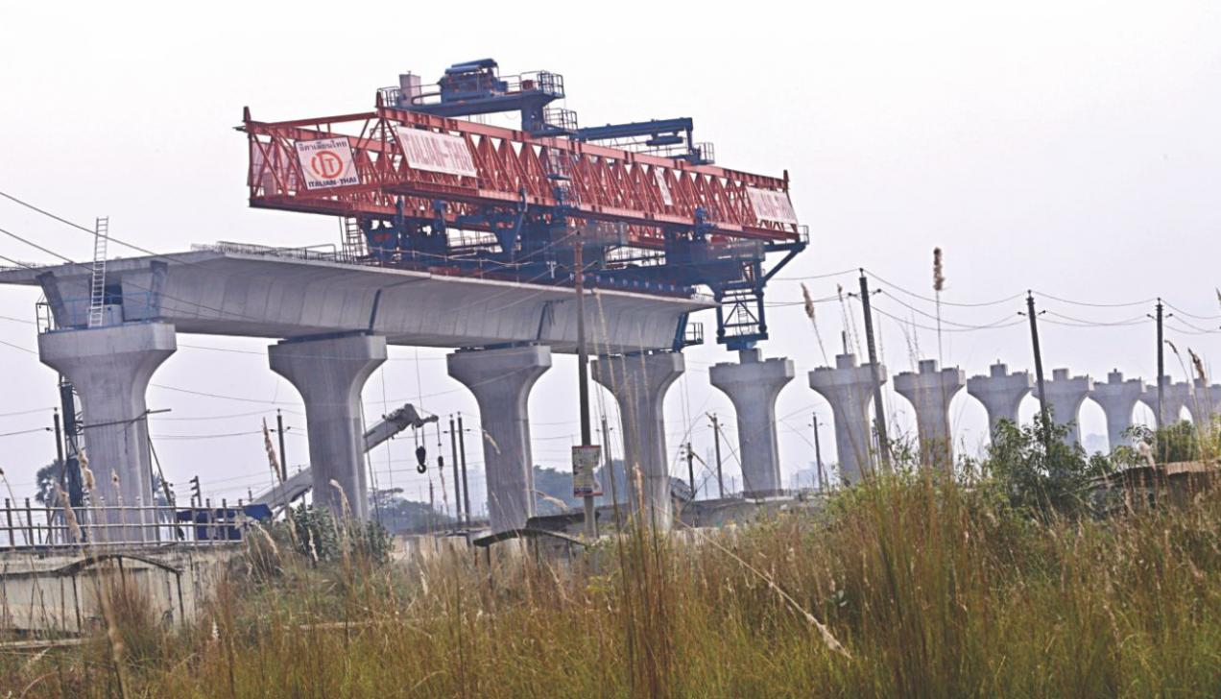  【Car market thriving on economic prosperity】  国の経済成長に伴って続伸する自動車販売市場。The automobile industry is passing through a good time for at least four years now thanks to the increase in disposable income and easy financing from banks and non-bank financial institutions.…11月16日Daily Star紙  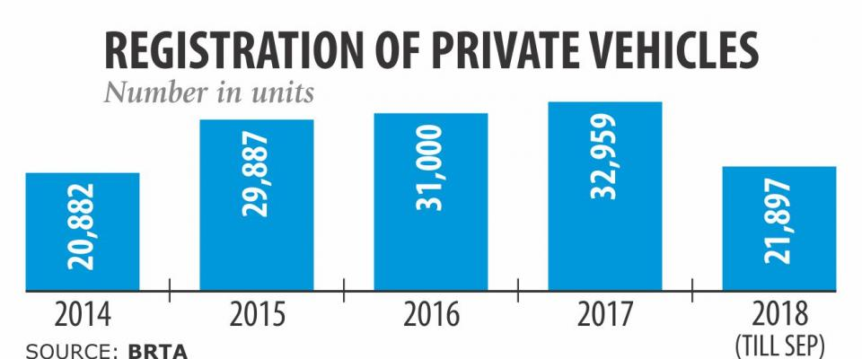  【One lakh people earning via Uber】  10万人もの雇用を生み出したUBER。Uber has changed the commuting ecosystem in big cities like Dhaka and Chattogram and created income opportunities for about one lakh people in the last two years, a top official of the world's largest ride hailing service provider said yesterday..…11月28日Daily Star紙    【Engine oil market expanding fast】  エンジンオイル市場が急伸している。Uber has changed the commuting ecosystem in big cities like Dhaka and Chattogram and created income opportunities for about one lakh people in the last two years, a top official of the world's largest ride hailing service provider said yesterday..…11月30日Daily Star紙  
製造業 |  | 【Japan’s Honda opens motorcycle plant】  ホンダの新・二輪工場が稼働する。Japan automobile giant Honda yesterday inaugurated its motorcycles manufacturing plant in Bangladesh, in what can be viewed as a watershed moment for the country's industrial capabilities..... 11月12日Daily Star紙  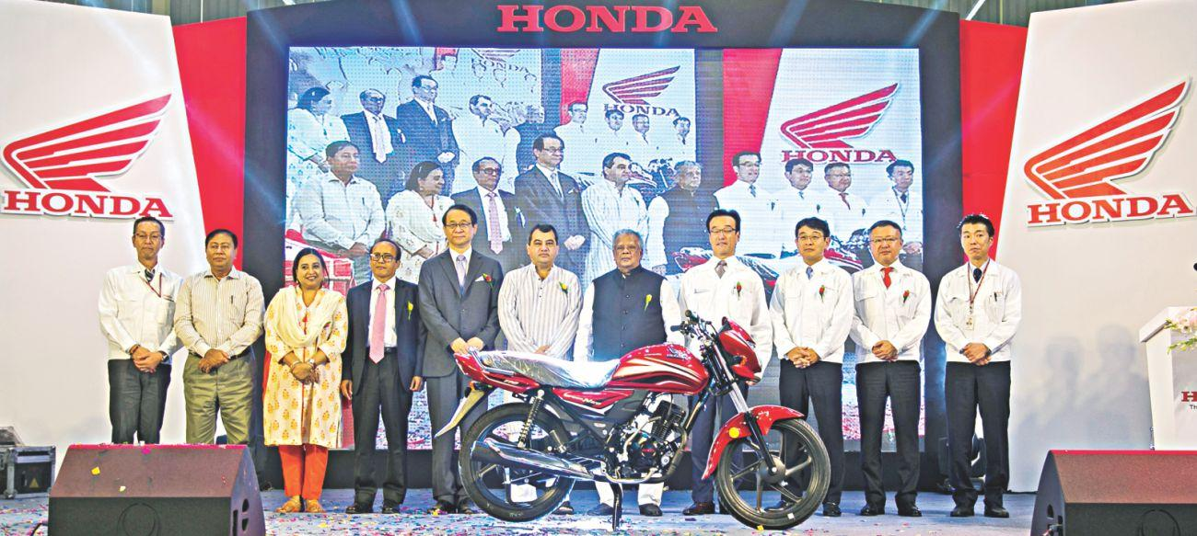  【Mitsubishi’s Setsuyo Astec Corporation starts journey in Bangladesh】  セツヨーアステック社Setsuyo Astec Corporation, a subsidiary of Mitsubishi Electric Corporation, has launched its representative office in the country to strengthen market survey, information collection and other such capabilities....... 11月30日Financial Express紙  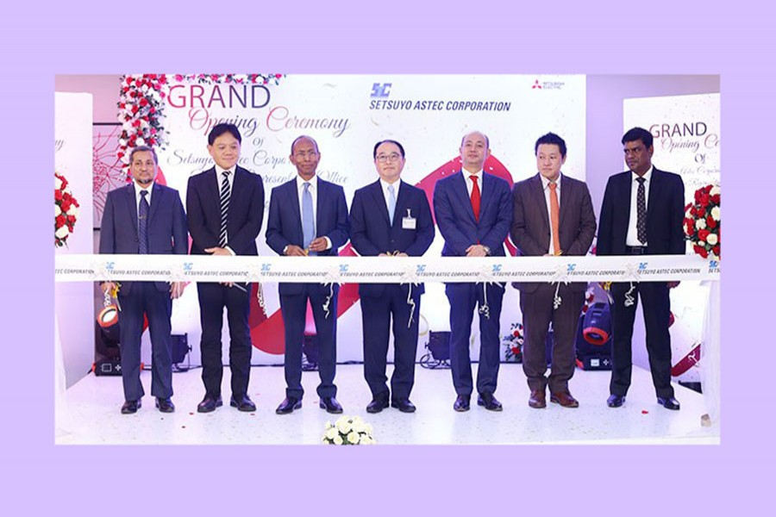
その他 |  | 【Coastal belt holds wind power prospects: study】  南部港湾地区は風力発電に適している。Bangladesh's southern coastal belt offers potential for generating power through wind, according to a recently published study by the US Department of Energy's National Renewable Energy Laboratory, raising hopes of meeting the government's renewable energy goals.... 11月11日Daily Star紙  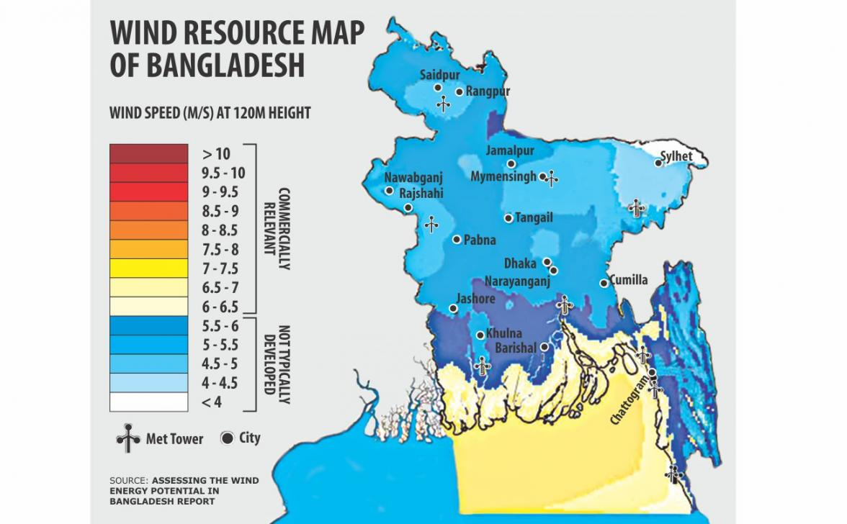
分野横断的ニュース
マクロ経済 |  | 【Bangladesh comes last in South Asia】  今年の「ビジネスのしやすさランキング」が発表され、南アジアの9か国中最下位に。  Bangladesh ranked 176th out of 190 countries in the World Bank's Ease of Doing Business index this year, which is the lowest ranking for a South Asian nation -- an alarming development given the government's claims of reforms to improve the score.… 11月1日Daily Star紙  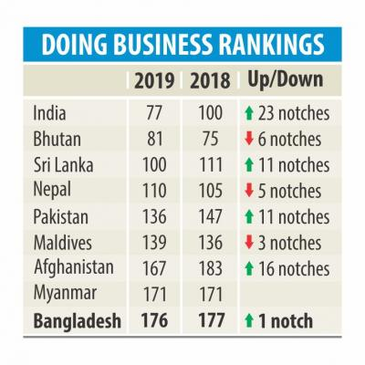  【FDI picking up, but slowly】  伸び悩むバングラデシュへの直接投資。Foreign direct investment in Bangladesh rose only 5.11 percent in fiscal 2017-18 from a year earlier -- the progress being slow because of inadequate infrastructure and poor ranking in the World Bank's Ease of Doing Business index....… 11月15日Daily Star紙  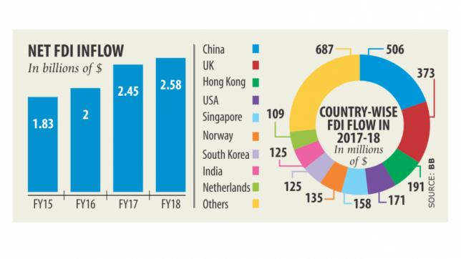  【China keen to invest in pharmaceuticals, apparel, leather sectors】  中国が着目するセクターとは。Chinese investors have shown their keen interest to invest in ceramics, pharmaceuticals, apparel, polyester staple fiber (PSF), leather and some other sectors in Bangladesh.....… 11月16日 Financial Express紙  【Cheap labour continues to draw Japanese investment】  2016年のテロ事件後、24社の日系企業がバングラデシュへの進出を果たした。進出の決め手は、廉価な労働力か。The devastating terrorist attack in Dhaka in July 2016 that killed seven Japanese citizens could not dampen the Far East nation's attraction towards Bangladesh when it comes to trade and investment......… 11月19日 Daily Star紙
貿易 |  | 【Export earnings jump 30pc in October】  繊維製品中心に輸出高に伸びが見られる。Export earnings climbed 30.53 percent year-on-year to $3.71 billion in October compared to the same month a year ago on the back of higher shipment of garment items...… 11月7日Daily Star紙
雇用問題  ジェンダー  その他  社会問題 |  | 【New apparel wage comes into effect next month】  最低労働賃金の引き上げがなされる。The labour ministry yesterday published a gazette on the wage structure of garment workers which would come into effect from next month......11月27日Daily Star紙  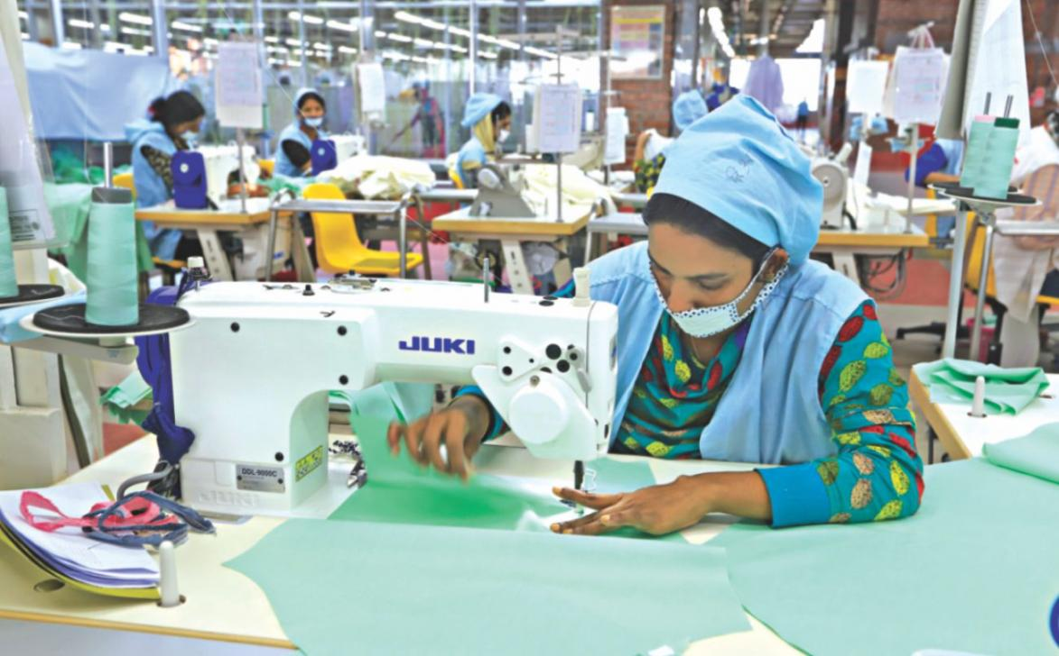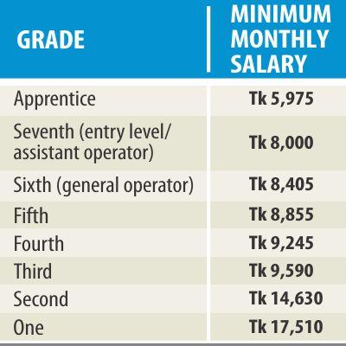  【68pc Bangladeshis pay no income tax: CPD survey】  所得税の納付率は伸び悩んでいる。Some 68 percent of the population do not pay tax despite having taxable income, according to a study by the Centre for Policy Dialogue.....11月9日Daily Star紙  【More women joining labour force: ILO】  さらなる女性の社会進出を。Female articipation in Bangladesh's labour force has increased to 36.3 percent in 2017 from 33.2 percent in 2016 thanks to the flourishing garment industry, according to a report of the International Labour Organisation......11月18日Daily Star紙

