バングラデシュ・ビジネス関連ニュース（2018年12月）
～主要ニュースの抜粋版～

（為替レート 1タカ＝1.366円）
産業別ニュース
アパレル  皮革 |  | 【Bangladeshi apparel to draw bigger FDI】  米中貿易戦争により中国等からバングラデシュへの生産移転を検討している企業が増えてきている。The ongoing trade war between China and the US will bring more work orders and more foreign direct investment for the garment sector of Bangladesh, according to the United Nations Economic and Social Commission for Asia and the Pacific (UN ESCAP)…..12月13日Daily Star紙  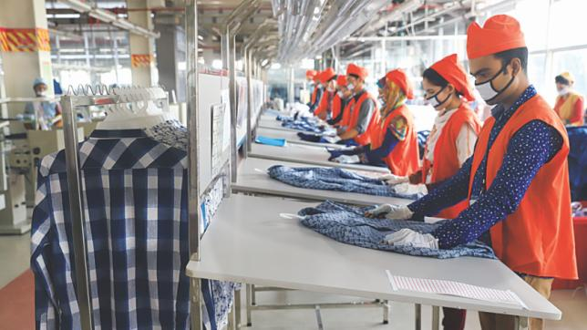  【Stimulus for jute millers】  繊維業の輸出促進のために、バングラデシュ政府はジュート産業の支援に取り組む。The government has offered a stimulus package to debt-stricken jute millers with a view to giving a boost to export earnings by the sector....... 12月5日Daily Star紙  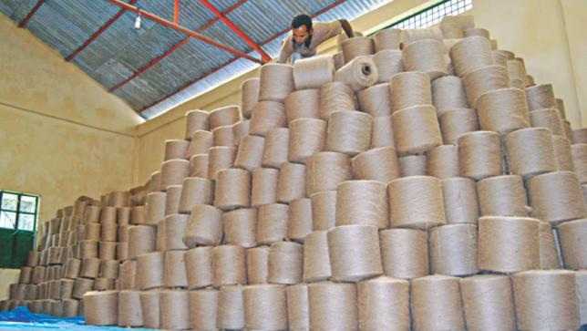
金融 |  | 【Green Delta, IFC bring insurance for farmers】  IFCは民間保険会社（グリーンデルタ社）と共に農家に農業保険を提供している。Agri-insurance needs government support to flourish, said insurance specialists yesterday. Around the world agri-insurance was introduced on public-private partnership, where the government plays a vital role,...… 12月9日Daily Star紙  【Bangladesh: most underinsured nation】  バングラデシュは世界の中でも突出して保険カバー率（GDP比）が低い。その分、未開拓の市場として注目を浴びつつある。Bangladesh is the most underinsured country in the non-life insurance category, standing to lose as much as 0.8 percent of GDP from natural disasters a year, said Lloyd's of London, one of the leading insurance markertplaces in the world..… 12月16日Daily Star紙  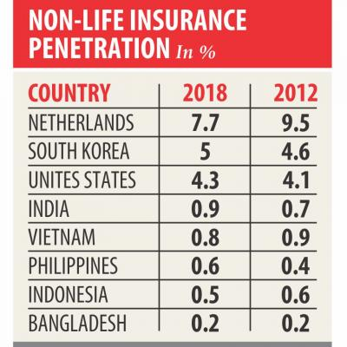
製造業 |  | 【Symphony's second mobile assembly plant by next year】  シンフォニー社が2つ目のアッセンブリー工場を立ち上げる。Symphony has started preparations to set up its second mobile assembly plant at Bangabandhu Hi-Tech City in Kaliakair, Gazipur within a year to make devices for other brands and export markets...... 12月3日Daily Star紙  【Auto parts market swells on rising demand】  自動車部品市場は堅調。概況↓  - Market size was Tk 1,300cr-Tk 1,400cr last year  - Annual growth rate 10-12pc  - Market size was below Tk 500cr 10 years ago  - At least 200 traders import auto parts  - Of the spare parts, 80pc are for Toyota cars....... 12月3日Daily Star紙  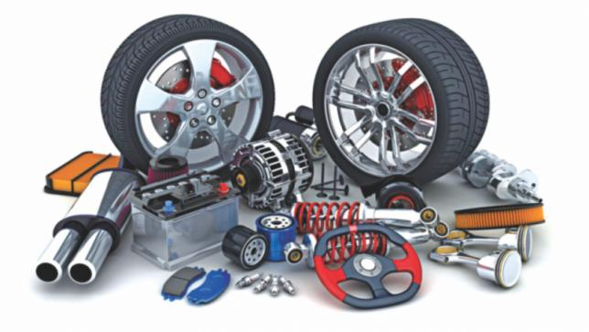  【Tk 100cr business】  熱を帯びる総選挙。恩恵を受ける製紙・印刷業。Election candidates' spending on campaigning posters is likely to create about Tk 100 crore of business for the paper and printing industries, which although a drop in the ocean for the Tk 7,200 crore market is being welcomed by printers and millers....... 12月5日Daily Star紙  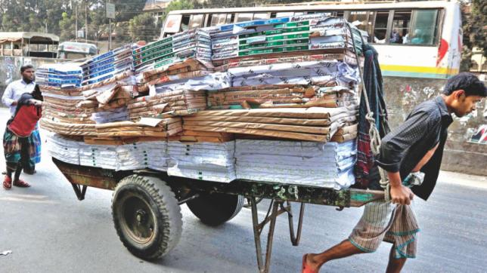  【Mitsubishi’s Setsuyo considers setting up factory in Bangladesh】  三菱電機グループのセツヨーアステック社はバングラデシュ進出を検討している。Setsuyo Astec Corporation, a subsidiary of Mitsubishi Electric Corporation, is considering to set up its factory in Bangladesh as the wages here is the lowest among the Asian and Oceania countries....... 12月12日Bangladesh Sangbad Sangstha紙
その他 |  | 【InterContinental opens to guests】  インターコンチネンタルホテルがダッカに進出。InterContinental Hotels Group (IHG), one of the world's leading hotel companies, has announced the commencement of commercial operations of InterContinental Dhaka in partnership with state-run Bangladesh Services Limited (BSL)...... 12月12日Daily Star紙  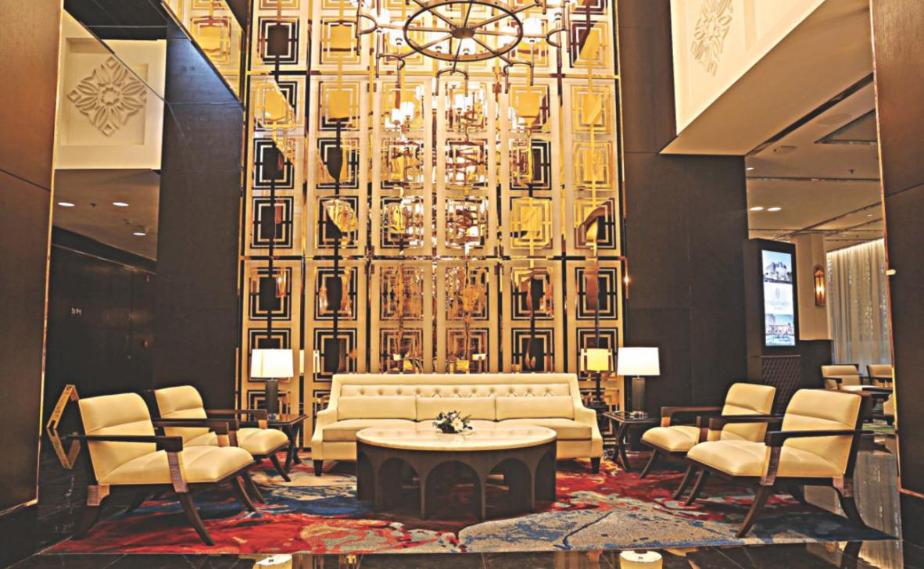  【Unilever to buy 82pc of GSK Bangladesh】  英蘭ユニリーバ社が、英製薬大手グラクソスミスクラインのインド・バングラデシュ栄養食品飲料事業を買収した。Unilever is set to buy 82 percent stakes in GlaxoSmithKline's health food and drinks business in Bangladesh for Tk 1,640 crore, as part of the Anglo-Dutch company's push to cash in on Asia's fast-growing economies....... 12月4日Daily Star紙  【Gas supply crunch spurs demand for electric cookers】  天然ガスの枯渇問題を背景に、電気調理器の販売高が増加している。Sales of electric cookers have soared in the country amid shortage of natural gas supply to households, said trade insiders. Rising incidents of LPG cylinder blasts has also prompted the consumers to turn to electric ovens, they added....... 12月13日Daily Star紙  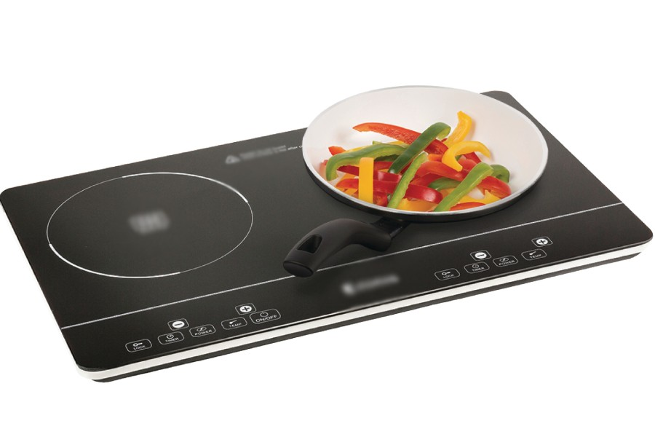  【Agora to invest $10m to double outlets】  スーパー小売大手（ローカル）のAGORAは目先2年間において10億ドルでアウトレット設立に向けた投資を検討している。Agora, the first retail chain in Bangladesh, is going to invest $10 million in the next two years to double the number of its outlets to cater to the growing demand of city dwellers, said its top executive........ 12月13日Daily Star紙  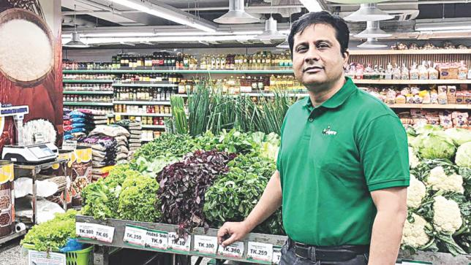  【Tourism booming with economy】  経済成長により人々の可処分所得が増えたことで、観光業が盛んになってきている。Bangladesh's tourism sector has grown with the pace of the country's economic growth in the past decade, as more and more people are having sizeable disposable income….12月14日Daily Star紙  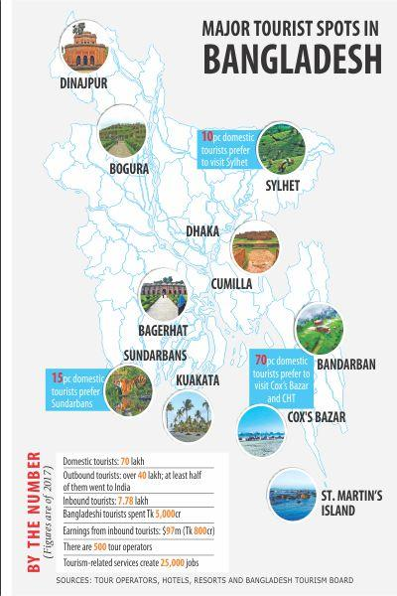  【Logistics, freight thrive on rising trade】  経済成長に伴いロジスティックス（運送）業の成長も顕著である。The logistics and freight industries in Bangladesh have been thriving for years in line with the steady growth of exports and imports, according to sector players.….12月25日Daily Star紙
電力 |  | 【Six eco-friendly power plants get go-ahead】  太陽光、風力などの5発電所プロジェクトの建設計画が進んでいる。The cabinet committee on purchase yesterday approved five solar power plants and one wind turbine power plant from which the government will purchase power at the rate of Tk 8 to Tk 9 per kilowatt-hour (kWh) for the next 20 years. ..…12月25日Daily Star紙
分野横断的ニュース
マクロ経済 |  | 【AL promises to implement 10 mega projects】  現与党アワミリーグは、選挙後政権が継続すれば10のメガプロジェクトを継続するとの宣言をおこなった。  Awami League (AL) President and Prime Minister Sheikh Hasina today promised to continue implementation of the ten mega projects taken by AL-led grand alliance government if her party is voted to power again in the upcoming general election..… 12月18日BSS紙  The 10 mega projects :  Padma Bridge, Rooppur Nuclear Power Plant, Rampal coal-fired Power Plant, Deep Sea Port, Dhaka Mass Rapid Development Transit Project, LNG Terminal, Moheshkhali-Matarbari Intregreted Infrastructure Development Project, Payra Sea Port, Padma Bridge rail link and construction of Rail track between Chattogram and Cox’s Bazar  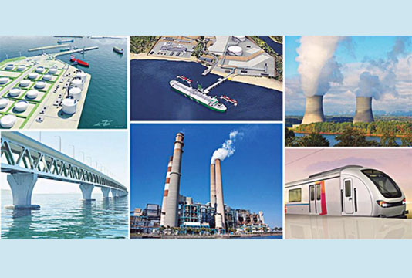
財政  税制 |  | 【Transfer pricing law starts paying off】  移転価格法案が成立して5年経った。移転価格税制は2019年から徐々に適用開始していく。After five years of its framing, transfer pricing law has started showing results, contributing additional taxes worth Tk 100 million...… 12月14日Daily Star紙  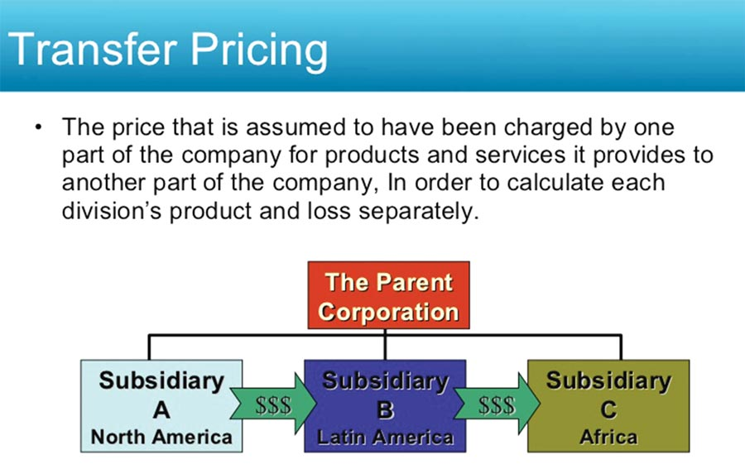
雇用問題  ジェンダー  その他  社会問題 |  | 【Health insurance brings smile to RMG workers】  繊維産業労働者への健康保険提供の取り組みがなされ始めている。Garment worker Mira breathed a sigh of relief when she learnt last November that she would no longer have to bear her healthcare bills.......12月17日Daily Star紙  