VI. ANNEX:
Country Report
Information and Data on Basic Energy and Power of your Country
All applicants are expected to fill the form and submit it with the Application Form to JICA office in your country by August 4th, 2017.
Country:
Name:
- Utility
- Major Electric Power Utilities(Public or Private)

- System of Electric Power Utilities
Situation of deregulation

Situation of unbundling the transmission and distribution sectors

- Availability of Energy Resources
- Reserve of fossil energy (if endowed) in Year 20?? ( Specify the year of data)
Fossil Energy | Estimated Amount of Reserve | Unit
Coal |  | Ton
Oil |  | Barrel
Natural Gas |  | m³

- Potential of Renewable Energy
Forms of Renewable Energy | Estimated Amount of Potential | Unit
Biomass in Year 20?? ( Specify the year of data) |  | Ton or m³
Hydropower in Year 20?? ( Specify the year of data) |  | MW

Form of Renewable Energy | Annual Average Irradiation | Unit
Photovoltaic |  | kWh/m²/day

Form of Renewable Energy | Annual Average Wind Speed with Specific Site Names  (Please select several representative sites) | Unit
Wind Power |  | meter/Second

- Annual Production of Fossil Energy (if produced)
Forms of Fossil Energy | Amount of Annual Production | Year of Production | Unit
Coal |  |  | Ton
Oil |  |  | Barrel
Natural Gas |  |  | m³

- Primary Energy Supply by Forms of Energy in Year 20?? ( Specify the year of data)
Unit: Joule or specify unit
Forms of Energy |  | Primary Energy Supplied | Percentage
Fossil  Energy | Coal
Fossil  Energy | Oil
Fossil  Energy | Natural Gas
Sub-Total
Natural  Energy | Hydro
Natural  Energy | Biomass
Natural  Energy | Solar
Natural  Energy | Wind
Natural  Energy | Geothermal
Sub-Total
Nuclear
Total |  |  | 100 %

- Final Energy Consumption by Sectors in Year 20?? ( Specify the year of data)
Unit: Joule or specify unit
Sectors | Final Energy Consumption | Percentage
Industry Sector
Social and Household Sector
Transportation Sector
Total |  | 100 %

- Installed Capacity of Power Generation Facilities (National Grid Connected) in a year of 20?? (Specify the year)
Generation Facilities | Installed Capacity (MW or kW) | Share (%)
Hydropower in Total
Conventional Hydropower over 10 MW
Small Hydropower between 10 MW and 1 MW
Mini Hydropower between 999 kW and 100 kW
Micro Hydropower less than 99kW
Thermal Power in Total
Diesel Power
Coal fired Steam Turbine
Oil fired Steam Turbine
Gas fired Steam Turbine
Gas Turbine (Single Cycle)
Gas Turbine (Combined Cycle)
Renewable Energy except for hydropower in Total
Grid connected Photovoltaic Systems
Grid connected Wind Power
Grid connected Biomass Generation
Other forms of grid connected renewable energy (Please specify)
Overall Total

Generating Capacity per Capita（kW/Capita）

- Electricity Generated by Grid Connected Generation Facilities in Year 20?? ( Specify the year of data)
Generation Facilities | Electricity Generated (MWh) | Share (%)
Hydropower
Thermal Power
Renewable Energy except for Hydropower
Total |  | 100 %

- Electricity Consumed by Sectors in Year 20?? (Specify the year of data)
Sectors | Electricity Consumed (MWh) | Percentage  (%)
General Household
Commercial
Industry
Agriculture
Government
Total |  | 100 %

Sales per Capita （kWh/Capita）

- Structure of Power System Supervision and Control
- Frequency Control
Centralized Operation at CLDC (Central Load Dispatching Center) or Not?

- Power System Control
Supervised voltage level and Control center supervising

- Manufacturer of SCADA System

- Combined Power System Losses in Year 20?? (Specify the year of data)
- Annual Total Electricity generated at generation end by all Power Stations on National Grid | MWh
- Annual Total Electricity sent out to National Grid | MWh
- Annual Total Electricity consumed by all Power Stations 【Power Station Own Use】 (A) － (B) = (C) | MWh
Power Station own use Rate (C) / (A) X 100 | %
- Annual Total Electricity sold | MWh
- Annual Total of Transmission and Distribution Loss 【Transmission & Distribution Loss】 (B) － (D) = (E) | MWh
Transmission and Distribution Loss Rate (E) / (B) X 100 | %

- Conceptual diagram of power flow from generating facilities to the customers
- Classification of Voltage for Interconnection (Transmission and Distribution)

- Transmission Line Route Length (km)
200kV or over
Under
total
- Distribution Line Route Length (km)
High Voltage
Low Voltage
total

- Household Electrification Rate
National Average of Household Electrification Rate  (=Connected Households / Total Number of Households) | %
Rural Electrification Rate  (=Connected Households in Rural Area / Total Number of Households in Rural Area) | %
Urban Electrification Rate  (=Connected Households in Urban Area / Total Number of Households in Urban Area) | %

VII. ANNEX:
Inception Report
Selected participants are requested to prepare an Inception Report, referring to the following format (Microsoft Power Point) as an example. The Report should be sent to JICA Kansai International Center via e-mail (ksictp1@jica.go.jp cc with Oi.Yoshiko@jica.go.jp) by September 20, 2017. Please make sure you meet the deadline, as the information in your report is valuable for the resource persons to adjust their lecture contents in advance.

NOTE: Participants in this program are requested to make a presentation on their inception report for about 20 minutes at the beginning of Core Phase in Japan.

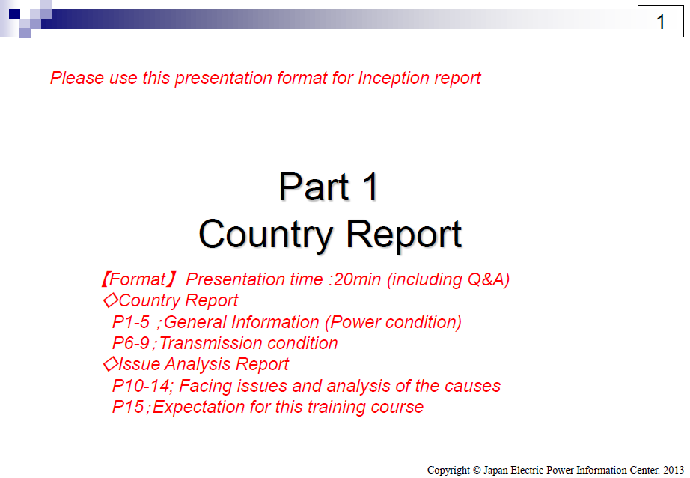

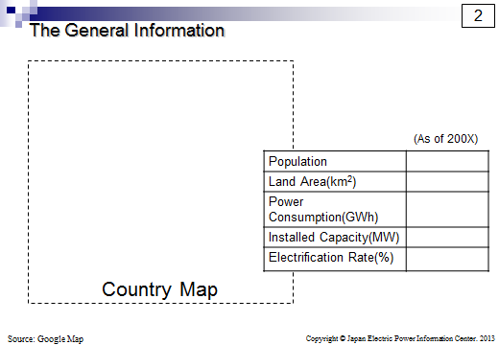

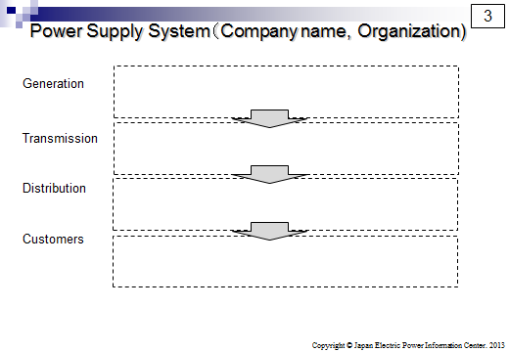

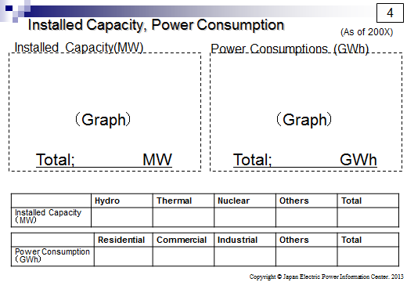

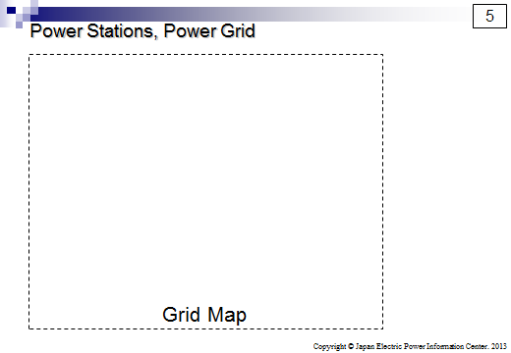

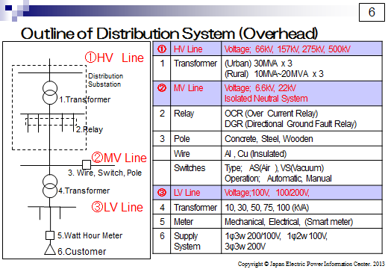

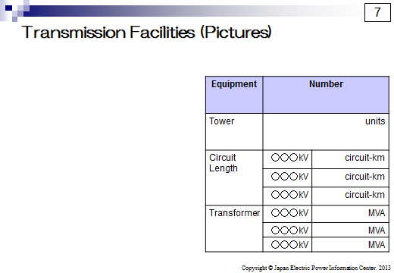

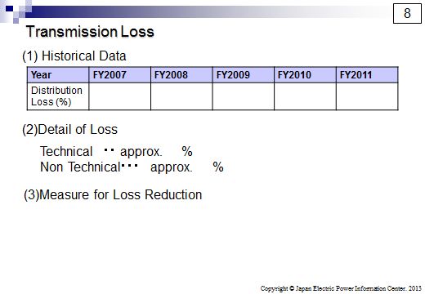

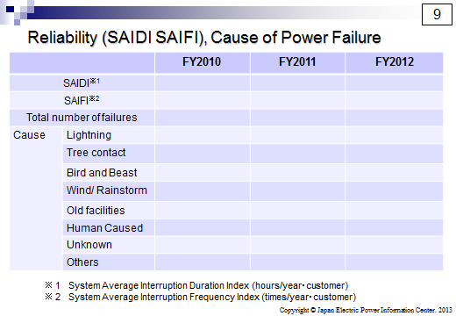

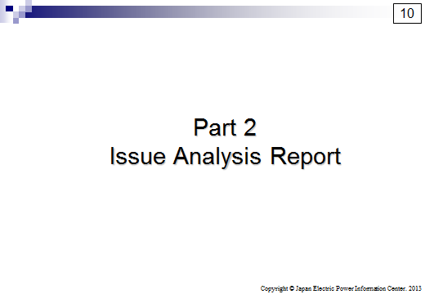

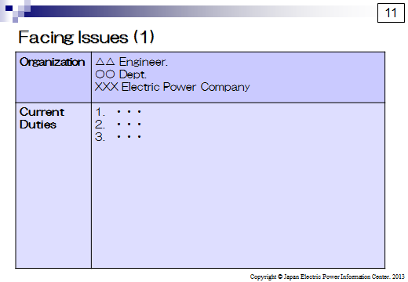

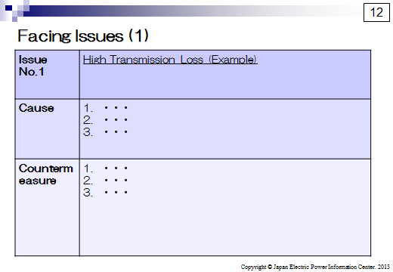

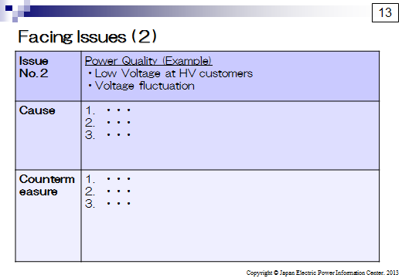

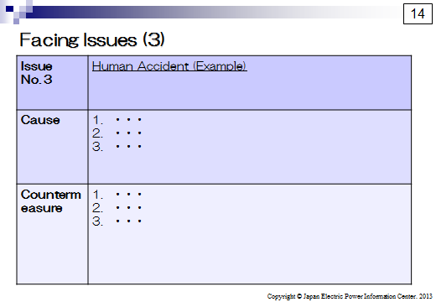

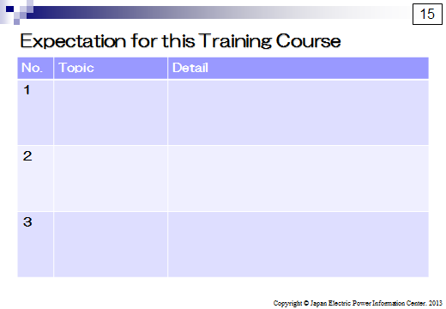

Primary energy is the energy that exists in nature without processing for or converting to secondary energy. Primary energy can be divided into three categories, fossil energy, natural energy and nuclear energy. Primary energy supply is the total amount of energy supplied to a nation.
Final energy consumption is a total amount of energy actuary consumed by the industry sector, the social and household sector, and the transportation sector in a nation as the form of primary energy, or the form of secondary energy that was converted or processed from primary energy. Secondary energy includes petroleum products such as petrol and kerosene, and electricity generated by thermal power.
Different countries use different definition to categorize hydropower. If your county has its own definition, you can use it and specify the definition in the table.

