Annex1

COMMUNITY-BASED DISASTER RISK REDUCTION
Job Report

A. Preparation of Job Report
Submission:
1)To be submitted together with your Application Form.
Note: Application without Job Report shall not be duly considered for selection.

2)Please submit Job Report in 2 formats of pdf and word.

*Please answer clearly and concisely. You may expand the space of each row and column of the format, if necessary.

1 Basic Information regarding you and your organization
1 | Name of participant  (Country) | ( )
2 | Your organization | Number of staff members:
3 | Your department, division, section or unit. | Number of staff members:
4 | Your job title and duty/assignment regarding  - Promotion of community-based disaster risk reduction  - Development / Establishment of community-based organizations.
5 | Please attach Organization Chart which you belong to (English preferably)
6 | The functions and authorities of your organization/department, regarding;  - Promotion of community-based disaster risk reduction  - Development / Establishment of community-based organizations.
7 | Please attach explanatory photos, showing how community-based disaster risk reduction works are carried out by yourself and at your organization.
7
  <example>
  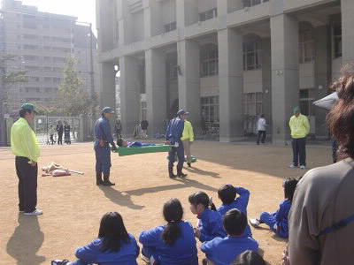  Staff of Fire Department conducting emergency training to school children | 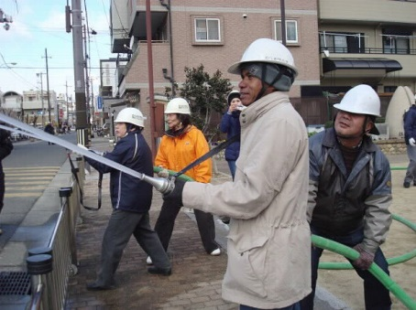  Community organization implementing a fire extinguish drill

- Problems (challenges or issues) which your organization faces

【Important】Please write about your problems and situations you would like to achieve at least one to two page to share your situation in detail.
Principal natural disaster in your area
Problems which your organization would like to solve regarding Community-Based Disaster Risk Reduction by obtaining knowledge and ideas through the program. Please write one to three important problems, which your organization wants to solve .
Problem1:

Problem2:

Problem3:
Situation you would like to achieve by solving the problem.
Problem1:

Problem2:

Problem3:
【Note: Problem Solving Chart】

In this program, you will formulate a Problem Solving Chart describing how to improve the situation which your organization faces related to community-based disaster risk reduction in each country by utilizing knowledge and ideas obtained through the program. The workshop about how to make a Problem Solving Chart will be implemented followed by individual online consultations. To prepare for the workshop, please fill out No.2 of job report to consider what kinds of problems your organization faces, etc. prior to the program.
【Reference: Topics of Problem Solving Charts made by ex-program participants.】

Case1: Establishment of Bokomi (community-based voluntary organization) based on the existing residential group by referencing to the example of Bokomi in Kobe.

Case2: Revision of disaster risk reduction plan at the community level.

Case3: Region wide awareness campaign for community by referring to the examples learn in the program.

