|  |  |  |  |
| --- | --- | --- | --- |
| No.16 | Communication English ⅡC | 番外編 | The Table of the World③ |

**⑥ An English Recipe “Khao Soi (カオソーイ)”**

Khao Soi … This is an local noode soup, meat and a tasty broth.

It has a mix of spicy, sour, and savory flavors from chili, lime and fish sauce(ナンプラー).

Ingredients (1x)

1. Cut the tomato into 8 equal pieces.

2. Finely chop the green onion, garlic, and

ginger.

3. Thinly slice the red onion. Cut the cilantro into 3cm pieces. Slice the lemon into 5mm pieces.

4. Heat the salad oil and the chopped ingredients from step 2 in a frying pan over medium heat. When the garlic becomes fragrant, add the ground pork and stir-fly.

5. Once the pork changes color, add the tomato and the seasoning ingredients from (A) while keeping it on medium heat. Stir-fry until the tomato breaks down and becomes soft, then remove from heat.

6. Boil water in a pot, add the pho noodles,

and cook according to the package instructions. Drain the noodles using a strainer.

7. In a separate pot, add the soup ingredients

and bring to a boil over medium heat. Once

it comes to a boil, remove from heat.

8. Place the boiled noodles from step 6 into a bowl, pour the soup from step 7 over it, then top with the ingredients from steps 3 and 5. Enjoy!

・Pho noodles: 100g

・Hot water (for boiling): as needed

・Ground pork: 100g

・Tomato (1/2 piece): 80g

・Green onion: 5cm

・Garlic: 1 clove

・Ginger: 1 piece

(A)Seasoning

・Iyo no Miso: 1 table spoon

・Doubanjang: 1/2 table spoon

・Ground chili powder: 1/2 tea spoon

(B) Other

・Salad oil: 1 table spoon

●Soup

・Hot water: 600 mL

・Chicken stock powder: 1 table spoon

・Nam pla (fish sauce): 1 table spoon

・Sugar: 1 tea spoon

・Salt and pepper: 1/4 tea spoon

・Cooking sake: 1 table spoon

●Toppings

・Red onion: 30g

・Cilantro: 10g

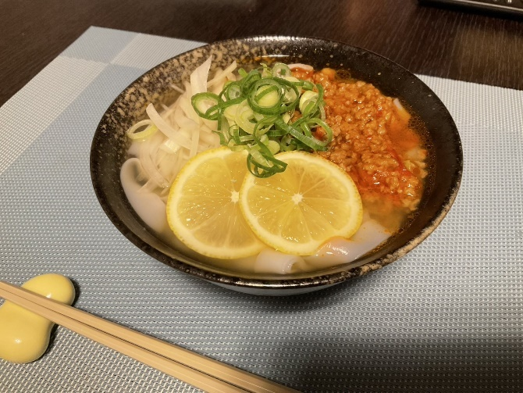・Shimanami Lemon: 1/2 piece