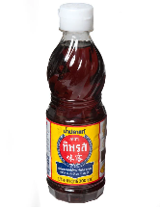
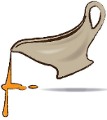
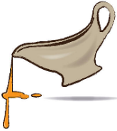
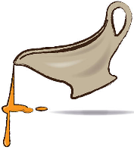
Nam-pla
Nam-pla
Gravy Sauce
Bacon
Gravy Sauce
Bacon
Gravy Sauce
Bacon


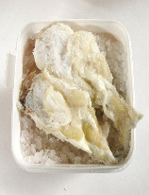
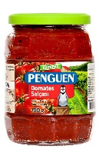
Bacalao
Bacalao
Salsa
Salsa
Salsa

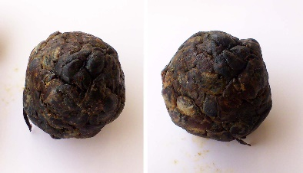
Dawadawa
Dawadawa
Dawadawa
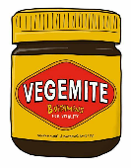
Vegemite
Vegemite

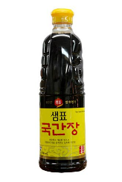
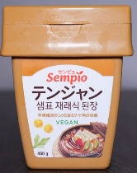
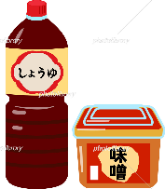
Gan jang
Ten jang
Gan jang
Ten jang
Soy sauce
Miso
Katsuo
Soy sauce
Miso
Katsuo
Soy sauce
Miso
Katsuo



Cheese, Ham
Oil Sardine

Cheese, Ham
Oil Sardine

Cheese, Ham
Oil Sardine

America | Australia | Brazil | Laos, Thailand | Turkey
Britain | Europe | Africa | Korea

