|  |  |  |  |
| --- | --- | --- | --- |
| No.21 | Communication English ⅡAB | 番外編 | Sustainable Tourim |

**0. Warm-up [Speaking]**

**Q.1 Where would you like to go during the winter vacation?**

A: Where would you like to go during the winter vacation?

B: I would like to go to ______________________________.

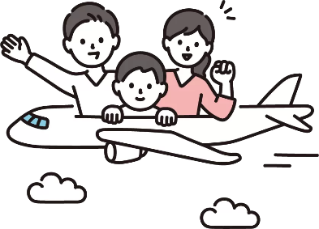A: (Reaction) What would you like to do there?

B: I would like to _______________________.

A: (Reaction)

B: How about you? Where would you like to go?

A: I want to go to ______________________________.

B: (Reaction) What would you like to do there?

A: I want to __________________________________.

HINTS

eat delicious local foods such as ～. : ～などの地元のおいしい料理を食べたい

visit famous tourist spots. It is famous for ～. : 有名な観光地を訪れたい。～で有名だよ。

enjoy shopping. I want to buy ～ : ショッピングを楽しみたい。～を買いたいな。

Reaction

Sounds interesting. / Really? / That’s nice. / I see. / Wow! / Oh!

**Q.2 Nowadays, many people enjoy traveling. Why do people travel?**

HINTS

・relax ・discovery (発見) ・health ・culture　・connection with others

**1. New Words**

|  |  |  |  |  |  |
| --- | --- | --- | --- | --- | --- |
| English | Part of speech | Meaning | English | Part of speech | Meaning |
| ① more than ~ |  |  | ⑤ overnight |  |  |
| ② handle |  |  | ⑥ trail |  |  |
| ③ hut(s) |  |  | ⑦ common |  |  |
| ④ bullet |  |  | ⑧ summit |  |  |

**2. Reading**

**What happened to Mt. Fuji?**

When Mt. Fuji was registered as a *World Heritage site in 2013, people all over Japan were thrilled by the news. Many hoped that more foreign tourists would visit Japan’s most famous mountain.

More than 200,000 people come to climb Mt. Fuji each summer, and it makes a lot of economic benefits. Also, Mt. Fuji has become very popular all over the world and many foreign people have understood the importance of Japanese culture.

However, this causes a lot of problems, too. Mt. Fuji can’t handle so many tourists. There are not enough beds in the mountain huts near the top, for example, and there are not enough toilets, either. This is why “bullet climbing” (climbing overnight without sleep) is so common these days. This just makes the trails near the summit more crowded, of course.

Q.1 2013年、富士山は何に登録されたでしょう？

Q.2 Q.1に登録された結果、富士山にどのような影響があったでしょうか？良い影響と悪い影響に分けて、日本語でそれぞれ具体的に説明しなさい。

|  |  |
| --- | --- |
| 良い影響 | 悪い影響 |
|  |  |