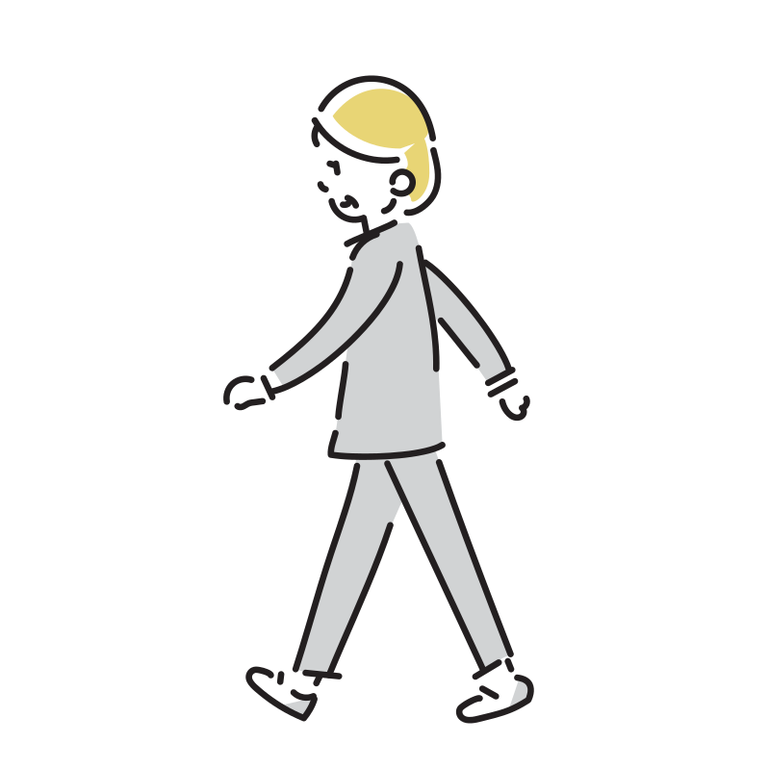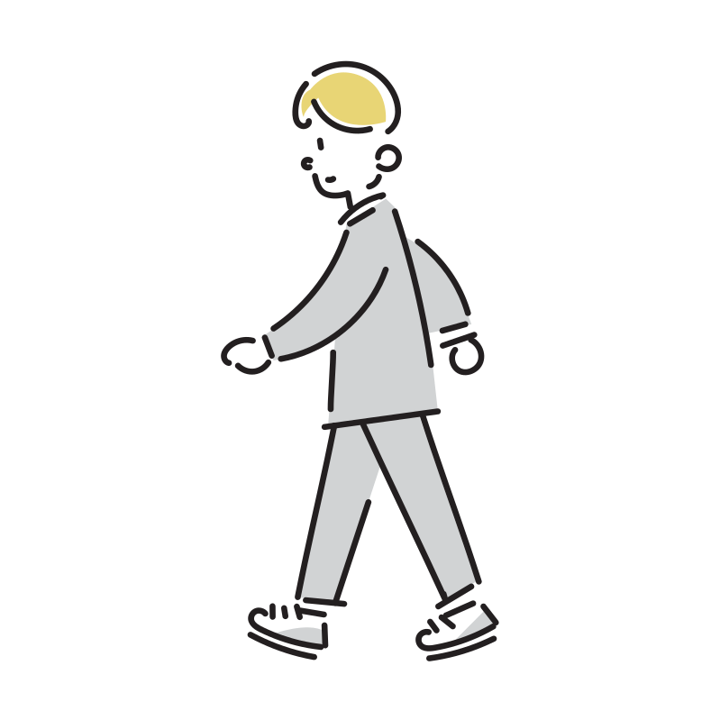一歩進め

|  |  |  |  |  |
| --- | --- | --- | --- | --- |
|  | 2 | 3 | 4 | 5 |
| 10 | 9 | 8 | 7 | 6 |
| 11 | 12 | 13 | 14 | 15 |
|  | 19 | 18 | 17 | 16 |