世界の森林の増減図：赤道付近の熱帯雨林が存在するエリアで特に減少が目立つ
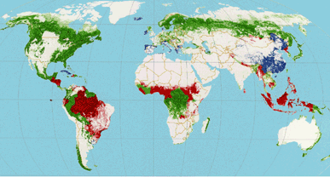

赤道→

出典：森林・林業学習館 https://www.shinrin-ringyou.com/forest_world/menseki_gensyou.php

