Ex. JICA Synthetic Business Management SBM 2009, Eng. Imad HAIDAR –Owner and general manager of Yamam, Fancy Yarns & Tufts, a private enterprise from Aleppo – Syria, reports:
A report on ex SBM Eng. Imad HAIDAR latest activities
- A co-operation with Japan Center for Academic Cooperation JCAC, Aleppo University AU, Aleppo – Syria, holding a 3 days training course on SBM & KAIZEN.
SBM trainees have promised and made an oath to transfer the information and the Japanese culture and state of mind, which they experienced and learned during their training and stay in Japan, to peers, colleagues and interested individuals in their own country.
Ex SBM, Eng. Imad HAIDAR and with the co-operation of JCAC in AU, have submitted a 3 days training course under the title of “Synthetic Business Management SBM – KAIZEN”. The course took place in the center’s well equipped main hall –which was equipped by the support of the Japanese government and JICA. The course went between the 9th and the 11th of April, 2013. Attendees were professors of different university divisions and specialties, university students, managers and interested individuals from the industrial and the managerial community in Aleppo – Syria.
Lately, and in an under-siege city of Aleppo, and in spite of a very severe situation and many difficulties as food, water, electricity and life necessities loss, clashes and blocked roads, a 3 days training course was safely concluded in JCAC main hall, more than 70 interested persons attended.
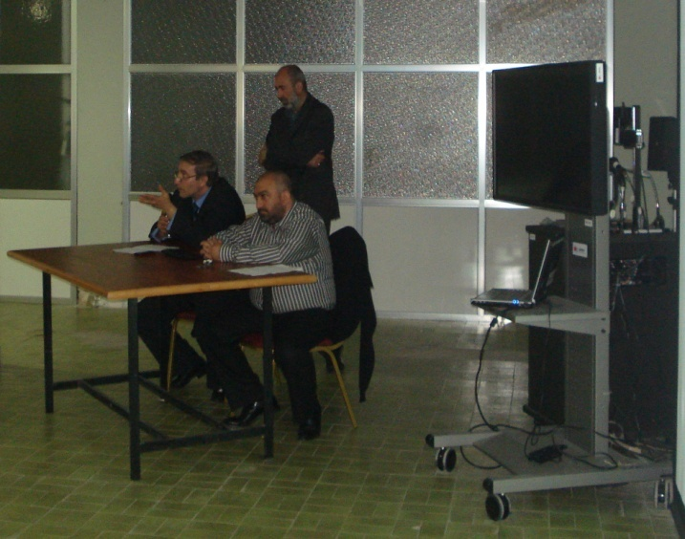
Dr. Ahmad AL-MANSOUR, associate professor of materials engineering in the Faculty of Mechanical Engineering – AU, and vice president of JCAC, introduced the lecturer and talked about the importance of such activities, courses and experiences to professors, university students and individuals, saying that such knowledge, culture and lessons, learned and taken directly from the rich Japanese experiences, past and present, will assist enhancing the managerial and operational environment and will be of a great gain locally. Dr. AL-MANSOUR expressed his and JCAC full support to the activities of the ex SBM trainees in the future.
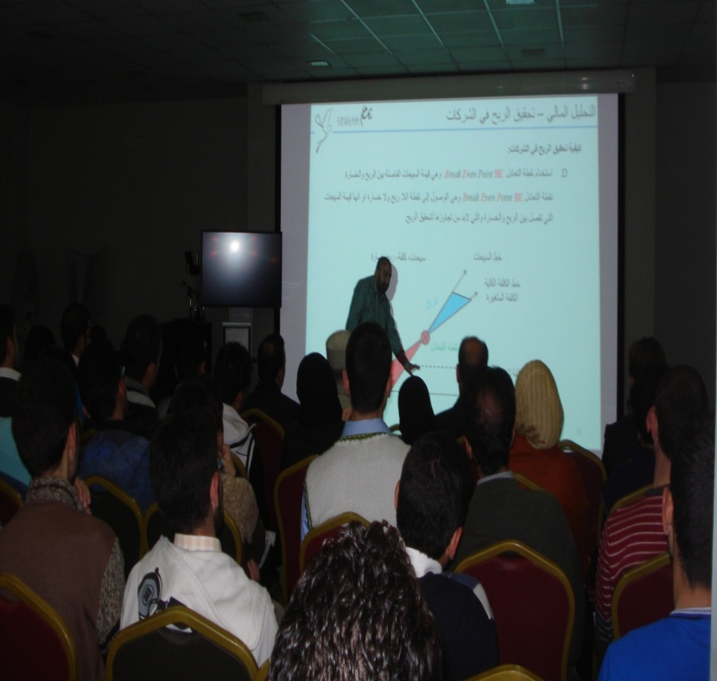
Dr. Jamil Sheikh OSMAN, an associate professor in Total Quality Management TQM, opened the training and talked about quality and its importance to the industry and the society, then stated that adding a special division on quality to the university curriculum in different divisions and specializations would be of a great significance.
The course main points were:
- Japanese individuals, their life experience and the state of mind, which helped the nation in defeating the odds after WW2 and facilitated lifting the nation to a very high position among other nations. Such experiences could be considered as a perfect role model and a lesson to be learned and followed after the Syrian crisis ends.
- Experiences and lessons learned by ex SBM Eng. Imad HAIDAR during his stay and training course in Osaka & Tokyo – Japan.
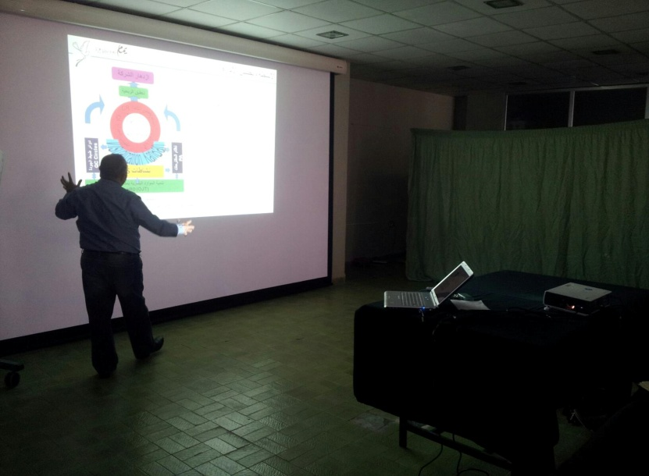
- KAIZEN and its activities, especially 5S activities which is the base of the improvement activities, Visualization as a tool to reveal the gap between the current situation and the goal, to find possible solutions and correct the course. Talked about KANBAN and the quality Deming or PDCA “Plan, Do, Check and Act” cycles, then talked about Suggestions activity and its benefits.
- Ways to raise the profit by lowering the waste, improving and transferring the working environment into a zero accidents, workers friendly one. Such knowledge is strongly needed under the current situation in Syria, to set standards for rebuilding, reviving and restoring the damaged Syrian industrial and societal body and setting it back to normal.
- The course was concluded by focusing on the importance of developing the human resources on the working sites or the On Job Training OJT and raising the staff ability and competencies to enhance and speed up the improvements activities.
Before finalizing last day of the course, a private message from Mr. Kazuyuki KUWADA –an ex JICA Senior Volunteer SV, a friend and a mentor who spent few years in Aleppo Chamber of Industry ACI, was delivered to the audience. The message wished for safety and for the Syrian crisis to end soon, wished for a better and safer tomorrow. It talked about the importance of the continuous ex SBM activities in transferring the knowledge SBM trainees had and experienced in Syria and in Japan. The message talked about the Japanese history and how the Japanese nation reacted while their down times to prevail over the difficulties and black days, talked about “WAKON YOSAI” and insisted on respecting and taking in mind the local spirit while utilizing the techniques and lessons learned, he also suggested that being “Open & Fair” should be the method to help Syria on the way to re-build and revive.
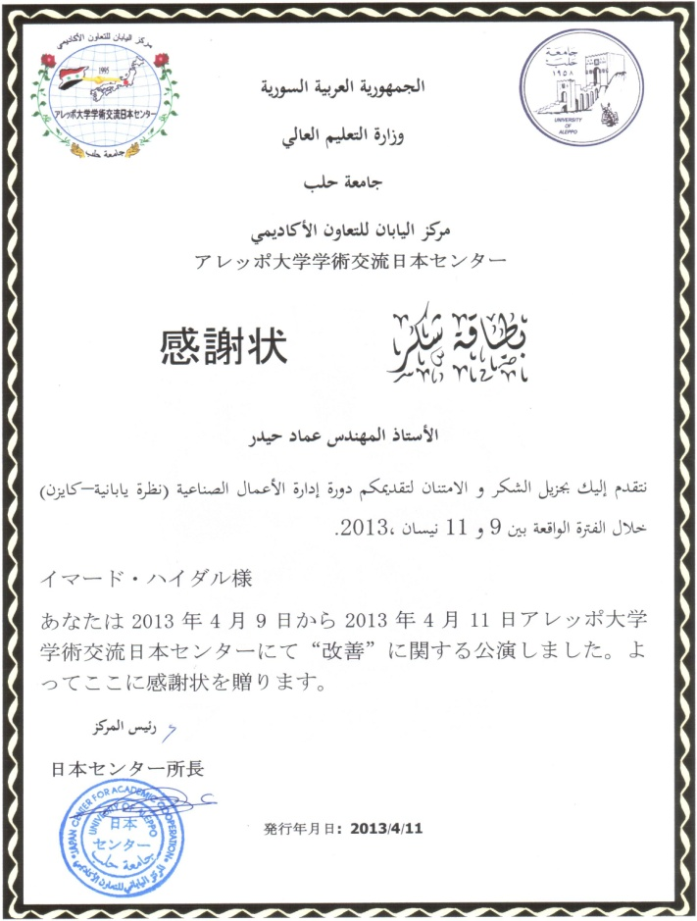
In the end of the course an attendance certificates were issued to the attendees and a thank you card was given to the lecturer by Dr. AL-MANSOUR, JCAC vice president.
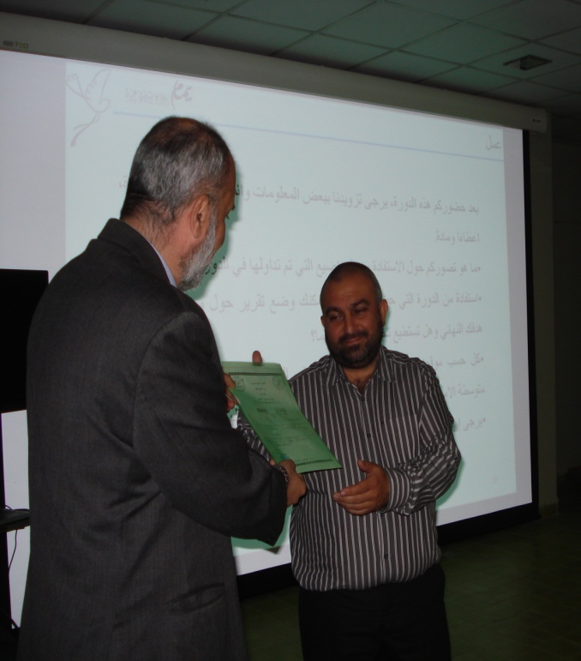
SBM training program lasted 5 years and trained a big number of Syrian managers of the private and the public sector, in Osaka & Tokyo – Japan, to depend on their knowledge after returning home, in transferring and spreading the technology, information and the Japanese culture and state of mind which they practiced and experienced in Japan, to the local, industrial and managerial bodies in Syria, all that shows and will demonstrate a great importance in promoting the Japanese methods of management that could help in raising the level of the Syrian industrial and managerial communities. Through the years JICA trainees in Syria have exceeded 1300 trainees in several specialties and divisions.

- The Synthetic Business Management SBM, The Japanese approach – KAIZEN Text book in Arabic language, “إدارة الأعمال الصناعية بنظرة يابانية – كايزن”.
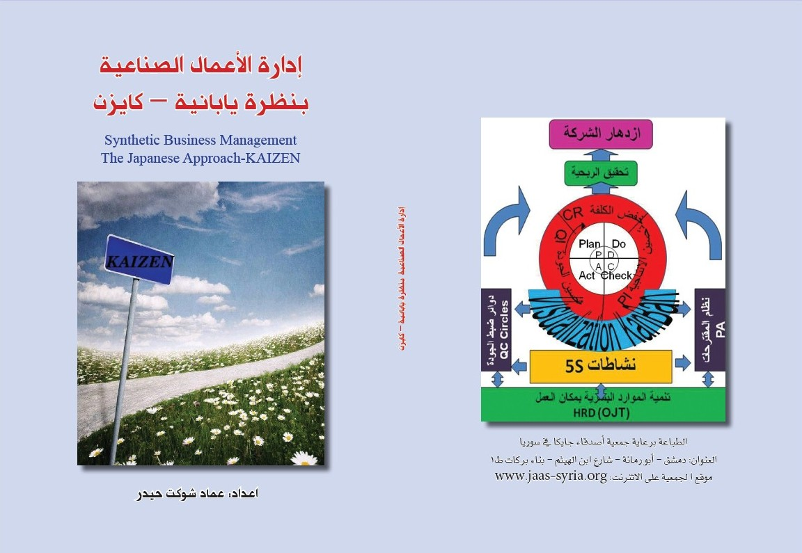
Ex SBM, Eng. Imad HAIDAR have finished editing and printing a text book in Arabic language about his Japanese experience and the lessons learned during his training in Osaka & Tokyo – Japan, as a way to simplify transferring the information, the knowledge and the lessons learned during his SBM – KAIZEN journey among the Arabic speaking nations.
The text book describes and talks about the Japanese experience, which targets, starts and depends on the human being and the individual. Japanese individuals believed in KAIZEN or the continuous improvements activities, used it and described it as a long journey but not a target in itself. Through this journey, many persistent and continuous activities and procedures are taken. It starts from the bottom of the pyramid i.e. the human resources, and moves towards the top of the pyramid with procedures and activities that aims at less waste, less accidents, less breakdowns and malfunctions, minimizing its percentage towards zero, eliminating the 7 Muda to reach a worker friendly work environment. Developing the human resources throughout the OJT and raising the quality of the product to reach the goal –through the accumulation of the improvements activities, which are a successful business and more profit as the main goal or target.
An illustration called the Japanese traditional house or the house of lean portrays the activities and shows its continuous cycles which is applied throughout the KAIZEN journey. Those activities are:
- 5S activities “Seiri, Seiton, Seiso, Seiketsu & Shitsuke”: as the starting point of the activities.
- Visualization.
- KANBAN and the Just In Time JIT production system.
- Proposal Activities PA and the Quality Control QC.
- Continuous PDCA cycles.
- OJT activities.
Taking in mind that the activities itself are not the goal, but a way and a road map to reach the goals.
The text book talks about the fundamentals of building the establishment depending on bases, rules and goals, setting a pact or a convention, a vision and a slogan. Staff and employees should have credence or total belief in those conventions and vision. Then it points out that the Object Management OM is one of the methods of management which goes as planning for a middle term goals as a step to reach the long term or the establishment goals.
It also talks about setting goals, levels and rules behind those goals. Then points out that at every beginning there should be an action plan that follows the PDCA “Plan, Do, Check and Act” or Deming cycles. It also describes the foundation behind adopting an improvement or a development, and the forms of the change expected while adopting it, and pointed out that a change could be a radical improvement or a motion one. It talks about goal patterns such as quality related, cost related, production related or safety related goals. The book was concluded by many samples, forms and examples supported by pictures and photos taken from the visited Japanese companies.
The text book includes an Arabic – English glossary with around 200 KAIZEN related acronyms, words and phrases.
Synthetic Business Management SBM, The Japanese approach – KAIZEN “إدارة الأعمال الصناعية بنظرة يابانية – كايزن” text book was printed in Damascus under the support of JICA Alumni Association in Syria JAAS, which supports ex SBM trainees activities after coming back home.
This book couldn’t have been possible without the support, training and mentoring of JICA SV’s, trainers and professors, Mr. Kazuyuki KUWADA, Schinichi OKADA, Ichihiro SAHARA, Teruhiko YOSHIOKA, Tetsushi FUKDA and the rest of the supportive and friendly JICA & PREX teams.
Ex SBM trainees’ activities is a live medium to exchange and promote the information and the Japanese culture and state of mind through time and distance, and a way to transfer the experience for the better of the nations. Such knowledge and culture could also be a road map especially in time of distress and troubles, to lead the path.
Japanese nation took a hard path after the WW2, which led them into a great success in picking up the nation from the bottom and total destruction to became one of the most civilized, successful and improved nations in the world, such path and activities could be used as a good example to be followed by other nations to rebuild and revive their own countries in all times.

