June 19, 2026
Duckweed Low-Carbon Water Treatment Group
At Professor Chart's laboratory in the Faculty of Engineering, Kasetsart University, I received a report on the progress since my last visit in March. 1) The duckweed wastewater treatment bench-scale test device installed on the university campus has been operating successfully for 60 days, and wastewater treatment and duckweed biomass production using the wastewater are progressing smoothly, allowing for steady accumulation of operation know-how. 2) The growth of duckweed in the pig farm's wastewater treatment pond has been recovering well since March. Furthermore, a new greenhouse gas measurement and recording device with several improvements has been completed, and students and I received an explanation of its operation from the manufacturer's technical staff. Before installing the device in the pig farm's wastewater treatment pond, we also exchanged opinions with Principal Researcher Dr. Yoshitaka Ebie of the National Institute for Environmental Studies Japan, who participated online, regarding the measurement method of generated gases, and we instructed them on the experimental procedure. In summary, preparations are nearing completion for the impact assessment on the circular economy toward realizing a low-carbon society, that is one of the achievement goals of this project. (M. Morikawa)
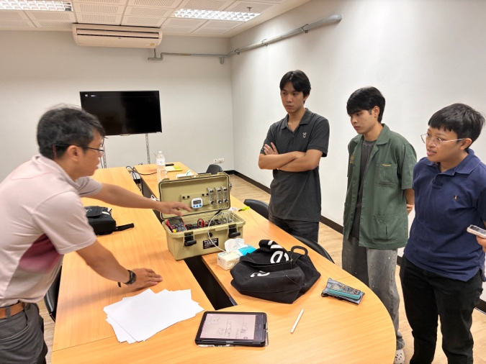
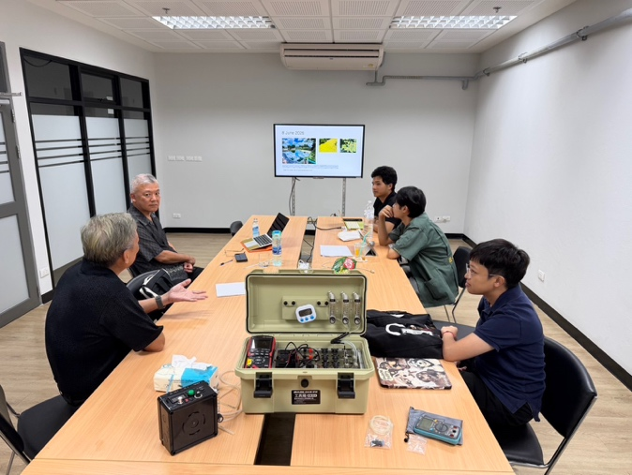

New greenhouse gas measurement and recording device and discussion

Note:
The project consists of six research groups namely: G1: Duckweed Holobiont Resource & Research Center (DHbRC). G2: Duckweed holobiont collection. G3: Duckweed holobiont analysis and biotechnology. G4: Duckweed biomass utilization. G5: Duckweed wastewater treatment technology. G6: Social implementation activities toward BCG economy.

