**Math and Science Teacher Technical Group**

**Pre-Training Study Materials**

**Nihonmatsu Training Center**



**This is an internal document for use at the Nihonmatsu Training Center and may not be copied or distributed without official permission.**

**©JICA Nihonmatsu Training Center, 2013**

**Jackie Newport, Jr.**

Acknowledgement:

Matthew Yomoah contributed some material for the technical content and specific purpose language tasks section.

Welcome to the Math and Science Teacher Training Program. You are about to take part in an intensive training program the objective of which is to prepare you to become a self-sufficient and fully functional math and science teacher. The program will prepare you to perform your host country JOCV assignment to your fullest.

The Program is intensive. You will only have about 70 hours of class time to acquire the language and teaching skills to enable you to meet the above objective. To be a competent teacher, you will need to focus on the tasks you will be given and do your best to accomplish each of them.

How much you will learn and how well you will be able to perform will be up to you. Your instructors will guide you, they will give advice and they will help you in any way they can, but you must make the effort to learn and use what you have learned.

You will find tasks that you must do below. Each of them plays an important part in the Program. You do not have to do each of them perfectly, but you are expected to do each of them to the best of your ability.

A schedule for the completion of the tasks is below:

Task 1 Complete the questionnaire and send it to JICA **before** you arrive at your training

center.

Task 2 Study the vocabulary related to your assignment and fill-in the self-study sheets

before you enter the Center. Give the results to the Language Section Staff **when you** **arrive** at the Center.

Task 3 Make the lesson plan following the instructions and give the results to the Language Section Staff **when you arrive** at the Center. Write the plan the same way you would for a lesson you will give in your host country.

Task 4 Read the orientation material **before** you arrive at the Center. The information in

it will be important for you to understand. The information will serve as

the basis for your training.

Task 5 Prepare the 3 minute speech **before** you arrive at the Center. It will be given in

your first Program class. Be sure to check the relevant information and

practice your speech.

Detailed information on each of the tasks follows. Good luck and, once again, welcome to the Math and Science Teacher Training Program at the Nihonmatsu Training Center.

Jackie Newport, Jr.

1

Task 1- Math and Science Teacher Trainee Questionnaire

Purpose: To give your instructor basic information about your background and expectations you

have for your training

What you need to do: Fill-in the questionnaire and send it to the training center by the postal service **before** you arrive at your training center.

2

**Math and Science Teacher Trainee Questionnaire**

**Please give complete and detailed answers in English to the following questions:**

1. What is your name and what would you like to be called in your classes?
2. What was your pre-JOCV job? (If you were a student, what did you study?)
3. Have you ever taught before? If yes, please give details such as how long, what level and so on.
4. Have you ever been abroad? If yes, please give details such as where, how long, why you went, etc.
5. Have you ever spoken to foreigners before you entered JOCV? If yes, please give details.
6. What is your JOCV host country and what is your assignment there? Please give details.

7) What are any problems you think you will have doing your assignment? Please give details.

8) What do you want to learn in your technical class? Please explain your answer.

3

Task 2- Technical content and specific purpose language related to specific assignments

Purpose: In your host countries it is generally assumed that a mathematics teacher knows and can

teach basic topics in science. It is also assumed that a teacher with a degree in science

also has enough knowledge of mathematics to teach it at the basic level. Even if your

assignment says you are going to be a mathematics teacher or a chemistry teacher, you

should still make good efforts to learn about the basic topics in other related fields. The material below includes general topics, expression and questions from science and mathematics.

Please review the language and contents related to these topics, especially in your own

field of specialization.

What you need to do: Complete the following task and give it to the Language Section Staff **after** you arrive at the Center.

4

Complete the following.

Part I

In your host countries, it is generally assumed that a mathematics teacher knows and can teach basic topics in science. It is also assumed that a teacher with a degree in science has enough knowledge of mathematics to teach it at the basic level.

Even if your assignment says you are going to be a mathematics teacher or a chemistry teacher, you should still make good efforts to learn about the basic topics in other fields.

The material below includes general topics, expressions and questions from science and mathematics. Please review the language and contents related to these topics, especially in your own field of specialization

1. Write the name of the branch of science that deals with things like the diagram below.

__________________________________

2. The picture below is the diagram of a common object. What is the name of this object?

___________________________________________

3. The names of 5 parts are missing. Write the name of each part on the line next to the arrow.

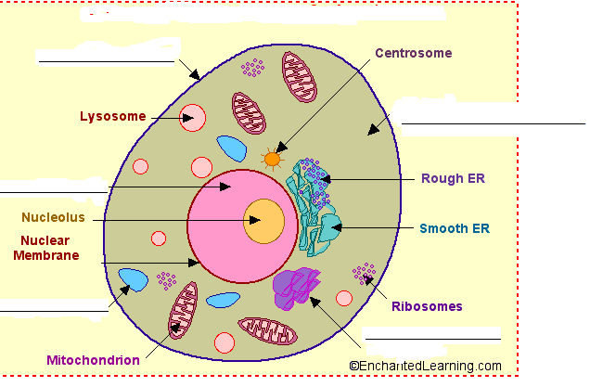

5

3. The table below shows some information about classification of living things. Put the following text box information into the correct columns and rows of the table.

multicellular form with specialized eukaryotic,

own means of locomotion

moss, ferns, flowering plants

multicellular, eukaryotic, no means of locomotion,

chlorophyll producing

unicellular, eukaryotic, some form chains or colonies

protozoans and algae

unicellular, prokaryotic

bacteria, blue-green algae (cyanobacteria), and spirochetes

multicellular, eukaryotic, filamentous form

sponges, worms, insects, fish, amphibians, reptiles, birds, and mammals

fungi, molds, mushrooms, yeasts,

|  |  |  |
| --- | --- | --- |
| **KINGDOMS OF LIVING THINGS IN THE LINNAEAN CLASSIFICATION SYSTEM** | | |
| **KINGDOMS** | **Description** | **Example** |
| **Monera** |  |  |
| **Protista** |  |  |
| **Fungi** |  |  |
| **Plantae** |  |  |
| **Animalia** |  |  |

4. Name 1 major organ in the human respiratory system.

_____________________________________________________________________________.

5. Which system does the heart belong to?

________________________________________________________________________________

6. What is the main function of arteries in the human body?

___________________________________________________________________________________________

7. What is the main difference between an artery and a vein in the human body?

________________________________________________________________________________________

8. Plants make their own food through a process using sunlight. What is the name of this process?

___________________________________________________________________________________

9. What is the name of the green matter in leaves which help in this process?

___________________________________________________________________________________

10. Which theory is Charles Darwin famous for?

___________________________________________________________________________________

6

11. What is the main function of red blood cells in the mammalian body?

_____________________________________________________________________________________

12. What compound in the red blood cell makes it able to combine with oxygen?

______________________________________________________________________________________

13. What do we mean when we say an insect is an organism with an exoskeleton?

__________________________________________________________________________________

14. What foods do we get carbohydrates from?

________________________________________________________________________________

15. What is the main nutrient we get from eating meat?

________________________________________________________________________________

16. The diagram below shows some of the names of parts in a flower. Write the missing names in the boxes.

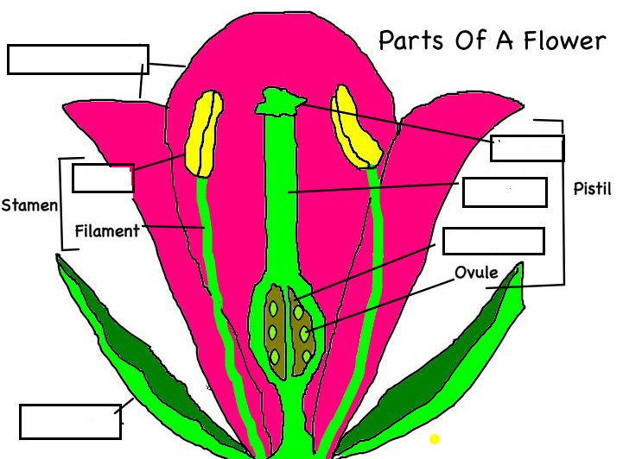

17. What is produced at the top of the filament?

_______________________________________________________________________________

18. What role does this material play?

___________________________________________________________________________________

19. What are *mitosis* and *meiosis*? Write two paragraphs in your own words to explain the differences between them. Draw diagrams to make your explanation clear to your students.

20. Write simple paragraphs in your own words to explain what the *circulatory system* is. Choose one living thing and describe its system. Please include a diagram to make your explanation clearer.

7

21. Write simple paragraphs in your own words to explain what the *alimentary system* is. Choose one living thing and describe its system. Please include a diagram to make your explanation clearer.

22. Write simple paragraphs in your own words to explain what the *respiratory system* is. Choose one living thing and describe its system. Please include a diagram to make your explanation clearer.

23. Write simple paragraphs in your own words to explain what the *immune system* is. Choose one living thing and describe its system. Please include a diagram to make your explanation clearer.

24. Write simple paragraphs in your own words to explain what the *nervous system* is. Choose one living thing and describe its system. Please include a diagram to make your explanation clearer.

8

Part II

1. The diagram below is a very simplified representation of the smallest portion of an element. What is the name of the branch of science which deals with the study of elements and their combination with each other?

_______________________________________________________________________________.

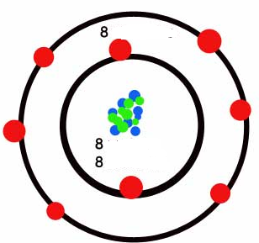

2. What do we call the smallest portion of an element?

_______________________________________________________________________________

3. Which element does this diagram represent?

_______________________________________________________________________________

4. What do the red balls represent?

______________________________________________________________________________

5. What do we call the two circles enclosing the green and blue dots?

_____________________________________________________________________________

6. What do we call the blue and green dots and the area they occupy?

_____________________________________________________________________________

7. What do the blue dots represent and what do the green dots represent?

_____________________________________________________________________________

9

8. Look at the next diagram. Explain why the green ball has a “- ” sign.

__________________________________________________________________________

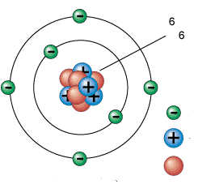

9. Explain why the blue ball has a “**+**”.

_____________________________________________________________________________

10. Explain why the red ball has no mark.

_____________________________________________________________________________

11. Write the name of the following elements and substances in the box below each one

|  |  |  |  |  |  |
| --- | --- | --- | --- | --- | --- |
| **K** | **Ca** | **Cl** | **Fe** | **Pb** | **Hg** |
|  |  |  |  |  |  |
| **Au** | **Zn** | **Mg** | **Na** | **Cl** | **P** |
|  |  |  |  |  |  |
| **H2SO4** | **NH4Cl** | **C6H12O6** | **NaCl** | **NaOH** | **HNO3** |
|  |  |  |  |  |  |
| **CO2** | **CaCO3** | **FeO** | **HNO3** | **H2CO3** | **HCl** |
|  |  |  |  |  |  |

10

12. Write in full sentences how you would read each of the equations below.

2 H2 + O2 http://www.science.org.au/primaryconnections/science-background-resource/data/images/arrow-small2.gif2 H2O

______________________________________________________________________________

4 Al + 3 O2 http://www.science.org.au/primaryconnections/science-background-resource/data/images/arrow-small2.gif2 Al2O3

_____________________________________________________________________________

|  |  |  |
| --- | --- | --- |
|  | heat |  |
| CaCO3 | http://www.science.org.au/primaryconnections/science-background-resource/data/images/arrow-small2.gif | CaO + CO2 |

__________________________________________________________________

13. Look at the diagram. What does pH stand for?

_____________________________________________________________________________

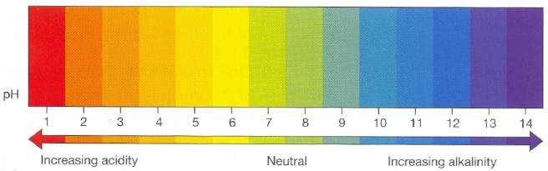

14. What word do we use to describe a substance if it measures 1 on this scale?

_____________________________________________________________________________

15. What word do we use to describe a substance if it measures 14 on this scale?

_____________________________________________________________________________

16. What word do we use to describe a substance if it measures 7 on this scale?

_____________________________________________________________________________

17. Explain the difference between a *mole* and a *molecule*. Use diagrams and examples in your explanations.

18. Explain the difference between an *ion* and an *atom*. Use diagrams and examples in your explanation.

19. Explain the difference between an *element* and a *compound*. Use diagrams and examples in your explanations.

20. Explain the difference between an *ionic bond* and a *covalent bond*. Use diagrams and examples in your explanations.

11

Part III

1. The 4 symbols in the table below are used for describing simple arithmetical operations. Follow the example and write the names of each one and a sentence to describe its use. Use the example to help you.

|  |  |  |
| --- | --- | --- |
|  | **Names** | **Use** |
| **+** | Addition sign  Plus sign | We use it to add numbers together. |
| **−** |  |  |
| **×** |  |  |
| **÷** |  |  |

2. Write the following in words: 7 **×**3 **=** 21

_____________________________________________________________________________

3. Write the following in words: 49 **÷** 7 **=** 7

_____________________________________________________________________________

4. Write the following in words: 10 **+**8 **=** 18

_____________________________________________________________________________

5. Explain the difference between an *odd number* and an *even number*. Use examples in your explanation.

6. Explain what a *whole number* is. Use examples in your explanation.

7. Explain the difference between *vulgar fractions* and *decimals*. Use examples in your explanation.

8. Look at the diagram below. What is the name of the branch of mathematics which deals with the properties and relationships of shapes, lines, points, etc.? ______________

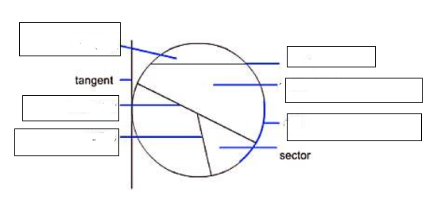

12

9. Write the names of the parts shown by the blue lines in the diagram above in their correct boxes.

10. What is a tangent? Explain it in your own words below.

_____________________________________________________________________________

11. Write the formula for finding the area of a circle.

____________________________________________________________________________.

12. Now complete the instruction sentence below to tell someone how to find the area of a circle.

*To find the area of a ________________ we _______________________________________*

____________________________________________________________________________.

13. What is the name of the branch of mathematics which uses letters of the alphabets to represent unknown numbers?

________________________________________________________________________________

14. Look at the mathematical expressions in the table below. Write how to say each expression in words.

|  |  |
| --- | --- |
|  | Expression in words |
| 52 |  |
| http://www.open.edu/openlearn/ocw/pluginfile.php/94445/mod_oucontent/oucontent/778/square_root_100.gif |  |
| (5 + 8)2 |  |
| 2−1 |  |
| http://www.open.edu/openlearn/ocw/pluginfile.php/94445/mod_oucontent/oucontent/778/mu120_b_i017e.gif |  |

13

Part IV

1. What is the name of the branch of science which deals with things like, matter, energy and force?

_______________________________________________________________________________

2. What is the difference between *potential energy* and *kinetic energy*? Use diagrams and examples in your explanation.

_______________________________________________________________________________

3. What does “*states of matter*” mean? What common example can you use to explain this concept?

4. What is the relation between *force* and *work*? Explain with examples and illustrations.

5. Explain what a *simple machine* means. Give 3 examples of simple machines. Include an explanation of “*effort*” and “*load*” in your response.

6. Explain the difference between *speed* and *velocity*. Include an explanation of the concepts “*scalar*” and “*vector*” quantities

7. What is the difference between *transverse waves* and *longitudinal waves*? Explain with diagrams and examples.

8. Explain how to measure waves. Include an explanation of the concepts *amplitude*, *wavelength* and *frequency*.

9. Explain *reflection* and *refraction* of light. Use diagrams and examples in your explanation.

10. Explain how a car jack works. What principle of science does the jack use?

11. Compare how the human eye and a pinhole camera work. Use diagrams in your explanation.

12. What is a magnetic field? Explain how to plot the magnetic field of a bar magnet. Use diagrams in your explanation.

13. What is Boyles’ Law? Use illustration in your explanation.

14. What problem can we use Fleming’s Left Hand Rule to solve? Use diagrams in your explanation.

15. What is Archimedes’ Principle? In what situations do we see this principle in use?

16. What are the Laws of Motion? State each one and write an explanation that 7th grade students will understand. Use diagrams and examples in your explanation.

17. What is the name of the law which tells us that energy cannot be destroyed or created? How can you show your students that this law is true? Write a lesson plan to demonstrate this law.

14

Task 3- Make a lesson plan

Purpose: You will have a very limited amount of time to not only improve your English language

skills, but also learn and use appropriate teaching vocabulary and skills. Your sample

lesson plan will help your technical class instructor prepare appropriate activities to

directly help you remedy any mistakes or problems you may have.

What you need to do: Choose one of the words or expressions that you have studied for Task 2 and

make a 15 minute lesson plan to teach that word or expression. You can use the

lesson plan template that follows to help you to organize your plan. Don’t worry

if you can’t do it well. Just try to do your best! Give the completed plan to the

Language Section Staff **after** you arrive at the Center.

You can use the lesson plan template on the next pages to help you to organize

your lesson.

15

### Lesson Plan

Presenter Name: Topic:

Lesson Target Time: Lesson Date:

Lesson Audience Level:

Lesson Objectives:

1.

2.

3.

4.

5.

Time Visual Aid/ Lesson Script

Used Whiteboard Time Visual aid/ Lesson Script

16

Used Whiteboard

17

Task 4-Read the orientation materials

Purpose: The orientation materials contain the basic information of what is expected of you as a

trainee, what you can expect from your instructors, how you will be judged during your

training and advice that will help you to survive and improve. Understanding this

information will help to avoid any misunderstandings about your training.

What you need to do: You need to read the information and to understand the contents **before** you arrive at the training center.

18

To: Math and Science Trainees

Fr: Your Technical Class Instructors

Re: Information about your technical classes

Congratulations on being selected as a Japan Overseas Cooperation Volunteer (JOCV) trainee and welcome to the Nihonmatsu Training Center (NTC). This orientation will give you some information before your classes start so that you can better understand what you will do here.

===================================================

**Who you are and what is expected from you**

Your technical class is designed for your JOCV host country assignment. All of you will be teachers, but you all have different levels of English and teaching ability. Do not worry! The purpose of this training is to give you as many chances as possible to use the English language ability that you have and to give you some basics on how to teach in an English language environment. We, your technical class teachers, want to make you better!

You will be expected to give around seven formal lessons from 40 to 50 minutes each in addition to a 15 minute sample lesson and a 15 minute practice lesson.

You will be expected to give your instructor a complete written lesson plan at least 24 hours before each performance to check and to give you suggestions for improvement. You should make revisions to your original lesson based on your instructor’s notes and suggestions and practice your revised lesson plan as many times as possible so that you will be able to teach it clearly and smoothly.

Making a lesson plan is only the first 50% of making you a good teacher. The other 50% comes from practicing your revised lesson plan. When you make a complete plan and practice it, you will have a 100% chance to perform at your full potential. Only doing one (i.e. writing your plan but not practicing it before your class) will only give you a 50% chance for doing what you really need to do.

====================================================

**What is expected from us**

We are your technical class instructors. We will help you to communicate and teach better in English. We will give you feedback and advice on your performance and we will try to help you to improve your communication skills. You will get that feedback and advice every time you perform as well as when you prepare to perform.

Giving classroom lessons as math and science teachers is the main focus you will have, but you will also study all of the necessary basics for teaching such as using teaching vocabulary, making visual aids, using teaching techniques and methods, test making and so on. You may have to study some of these basics in special teaching workshops held outside of the normal class hours because of the limited time we will have for technical classes (only about 70 total hours in the training period).

In summary, we will help you to learn and use general skills and techniques for teaching, but in the end, it is up to you to learn and use them- the same way that it will be up to you in your JOCV host country.

19

**Choosing topics for your training**

One of the things you will study here is how to think and plan clearly. The first step is to make a list of topics for your JOCV host country assignment. To do that, you will need to think about what you feel will be most useful for you to study and practice here in your training center. The topics you choose should be connected to your JOCV host country work and they should be challenging or useful for you to practice before you go to your host country.

You will be shown some examples of the methodology that previous math and science teachers used in their host country. After you have seen what has been done, you will need to make your own list of planned topics that you want to practice teaching. For example:

You can use a host country syllabus to find what you must teach in your future assignment and

you can choose your lesson objectives from that syllabus.

You can use a host country textbook that is suitable for your future class level and practice using

the lesson objectives written for each part of that book.

If you don’t have any teaching experience, the above information may sound too difficult. Don’t worry! You will study how to do it in your technical class. The reason for giving you this information now is to help you to understand what you will do in this class.

**How you will be judged**

Your ability to communicate in English will be judged by the items in the “Can Do List.” (See Appendix 1). The List has the skills that you will need to succeed in your JOCV assignment. Your technical class teacher will score you on the List items at the end of the training program. The final List will go to your host country JICA/JOCV coordinator to ensure that your language level will meet your assignment demands.

You will also be scored for each of your lessons by your classmates, each technical class instructor and yourself using the sample evaluation and feedback forms for each lesson. (See Appendix 2). Your classmates and instructor will use the “Peer Evaluation” form and you will use the “Self-Evaluation” form.

The purpose of these different forms is to give ideas and advice for how to improve your speaking and teaching ability in English.

**If you have trouble**

There may be times when you cannot do what you must do for your technical class. For example, you cannot give your instructor your written lesson plan by the deadline or you did not practice enough for your performance.

**Do not** hand in your lesson plans late. **Do not** come to class late. **Do not** think you don’t have to prepare for your lessons. If your work is late, you come to classes late or if you don’t prepare for your math and science classes in your host country, then you will make a bad impression on your host country’s people.

Those kinds of poor behavior are not acceptable anywhere. They will make you and JICA/JOCV look bad and they will hurt the students of your host country.

20

**The JICA Assessment**

Each week, your technical class instructor must submit a Teaching Record to the staff. The Record includes an assessment of your performance in class. You will be judged according to the contents of the Record found in Appendix 3. The report of your performance will be clear and the consequences for poor behavior can be harsh. Be careful!

===================================================

**Helpful Ideas**

Here are some ideas that can help you to have a more successful training:

1) Don’t be shy!

There are many reasons for being quiet in class, but learning to speak a foreign language well is

the same as having any other skill. You have to practice doing it many, many, many times.

Some people have an idea that it is OK to be quiet. Some people don’t want to talk because they are afraid of making mistakes. Some people don’t like to speak in front of other people.

They are all wrong! If you don’t practice speaking as much as you can in English, then you will not be able to express yourself clearly. Then your future life in your host country will be more difficult!

2) Mistakes are good.

You are learning how to communicate your technical knowledge and ability in a foreign language, English. It is natural to make mistakes and to have problems! Don’t be afraid of them!

Mistakes are good if you learn from them and don’t make them again and again in the future.

3) Honestly look at yourself

If you want to be a better communicator in English, then you have to honestly look at your weak points and try to fix them. Your classmates and technical class instructors will use the peer evaluation forms to give our advice for fixing them. What we say may make you feel bad and even angry, but keep in mind that we want to help you.

Do not try to escape from who you are or what you did. Do not think that we are trying to hurt you. Do not get angry!

The best chance you have to improve yourself is to listen to what others have to say and try to make the changes that you think will help you.

4) Don’t wait until it is too late

You have a schedule. You know when you must perform. You know that you have to give your fully written lesson plans at least 24 hours before your performance. You cannot say that you did not know. Manage your time so that you will be able to learn and will be able to perform well!

Some people wait too long to start or to do their work product. For example, the stay up the night before the due date and try to write their work product. They, of course, will be tired and they will make many bad mistakes. They will also feel more stress and more problems will happen. They will not be ready and they will not do well. You can be ready and perform well, but it is up to you!

21

**Your first assignment**

**Part 1**

You are to give a minimum 3 minute speech in your first technical class **in English** about your host country, your future school and what you will do there. You will need to gather as much information about it between now and your speech date (your JICA Data Sheet is a starting point).

The purpose of this speech is to get you to think, act and speak more comfortably in English and to help you understand your future role as a math and science teacher. You need to prepare for it as much as possible.

After you have finished making your speech, each of your classmates will ask you one question in connection to what you have said. Those questions will be good English practice for them to ask and for you to answer. You might also guess what questions people will ask you so that you can prepare and practice answering them before your speech.

**Part 2**

In your second technical class, you must give the lesson you made for Task 3 of this webpage to your technical class. Your instructor and classmates will watch and give you feedback on your performance.

==========================================================================

**Summary**

You have been chosen to become a math and science teacher. You have a wonderful assignment in that your students will be able to get a good education from you and use that education to get a better life.

Being a teacher is a heavy responsibility, but it can be a life rewarding experience that can also help another person. Let’s work together to make this world a better place.

Your technical class instructors

22

Appendix 1- Sample of “Can-Do List” in English

**Can-do items table for trainee self-evaluation**

Trainee’s Name:________________ Job: _______________ Date: ______________

T. Class Teacher: _________________________________

|  |
| --- |
| **Tasks**  **Can** |
|
| 1. Follow simple orientation instructions in preparation for job-related activities |
| 2. Make simple questions to get basic facts or more explanations |
| 3. Show someone the necessary actions for completing a job task using very simple language |
| 4. Say what is happening, what will happen, or what has happened while demonstrating a skill |
| 5. Describe how a mechanical, natural, or social system works in simple sequenced statements |
| 6. Give detailed instructions on how to do a job, or on how to use a principle or formula to solve a problem |
| 7. Give warnings and explain what will happen and why it will happen if we do or don’t do something |
| 8. Change the technical language of a theory, equation or concept into more simple language |
| 9. State professional titles and explain personnel roles in profession or technical field |
| 10. Name common tools, materials, parts of equipment, etc. in job area and state their uses |
| 11. Read or listen to and understand books, articles or lectures about the technical subject |
| 12. Name basic topics, concepts, equations, symbols, etc. in technical subject area |
| 13. Check audience’s knowledge and skills level and decide what they need to learn |
| 14. Make the objectives for a lesson, workshop, community projects, etc. to teach knowledge or skills |
| 15. Choose the necessary information and activities for teaching a lesson |
| 16. Make the questions or test tasks to check how much my audience have learned |
| 17. Prepare and give full lessons, workshops or presentations by myself |
| 18. Make original plan and choose contents for a full technical information and skills course |
| 19. Write or present a project proposal or report |
| 20. Make an audience change their attitudes or habits or make them agree to cooperate |

23

Appendix 2- Peer and Self Evaluation Forms

**Lesson Evaluation Form**

**Speaker: _______________________ Subject: _______________________ Date: ____________**

**Introduction Poor Minimum Good**

Ability to catch the audience’s attention ____ _____ _____

**Lesson Body P L M G E**

Main points are clear __ __ __ __ __

Key vocabulary words written __ __ __ __ __

Explanation of main points __ __ __ __ __

Check for audience comprehension __ __ __ __ __

Use of examples __ __ __ __ __

Audience participation __ __ __ __ __

Organization of lesson __ __ __ __ __

**Presentation of information P L M G E**

Use of general vocabulary __ __ __ __ __

Ability to answer audience questions __ __ __ __ __

Time management __ __ __ __ __

Preparation for this lesson __ __ __ __ __

Eye contact with audience __ __ __ __ __

Self-confidence of speaker __ __ __ __ __

**Conclusion Poor Minimum Good**

Summary or conclusion was made ____ _____ _____

Check of audience comprehension ____ _____ _____

**P = Poor performance L = Lacking performance M = Minimum performance**

**G = Good performance E = Excellent performance**

**Your feelings about today’s lesson (Circle one)**

Excellent Good Fair Difficult Poor

**Your suggestions to improve the lesson (Write them below)**

24

**Self- Evaluation Form**

**Speaker: ___________________ Subject: ____________________ Date: ___________**

**A) How did you feel about the lesson? (Circle One):**

Very good Good Fair Not too bad Bad

**B) What were the good points of the lesson? Please list them below:**

**C) What were the bad points of the lesson? Please list them below:**

**D) What changes would you make in the lesson to make it better? Please list them below:**

25